**Amazon web servcies AWS (CLF-C02)**

**Module 1: Introduction to Amazon Web Services**

* Summarize the benefits of AWS
* Describe differences between on-demand delivery and cloud deployments
* Summarize the pay-as-you-go pricing model

1. **What is cloud computing?**

* Cloud computing is the on-demand delivery of compute power, database, storage, applications and other IT resources.
* Through a cloud service platform with pay-as-you-go pricing.
* You can provision exacetly the right type and size of computing resources we need.
* You can access as many resources as you need, almost instantly.
* Simple way to access servers, storage, database and set of application services.
* Amazon web services owns and maintains the network-connected hardware required for these application services, while we provision and use what we need via a web application.

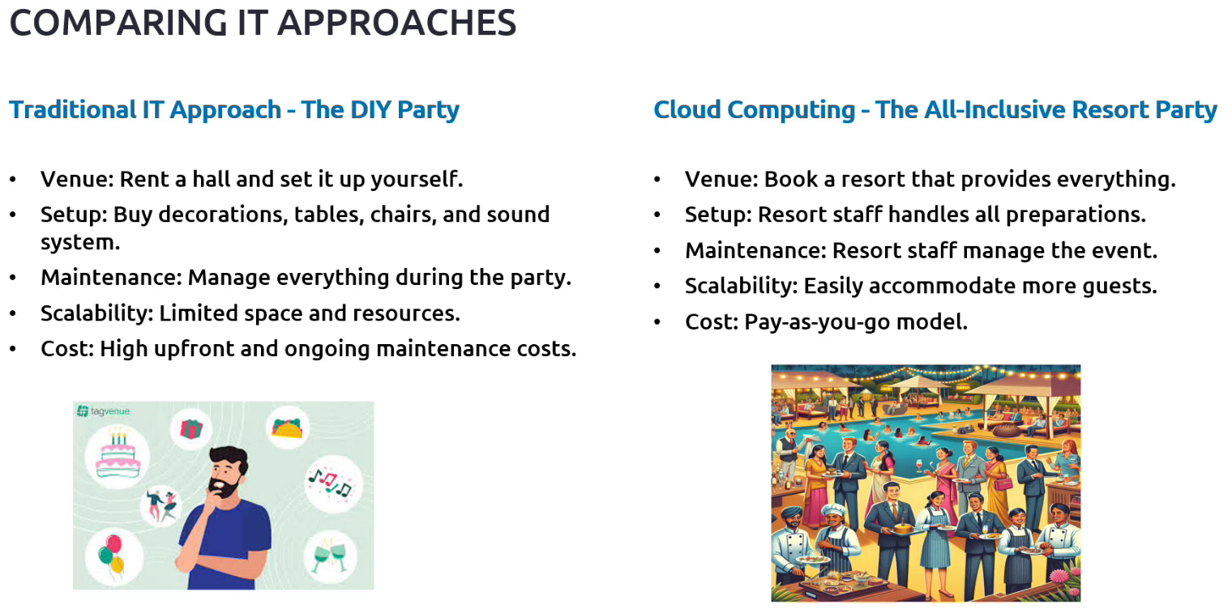

1. **Problems solved by the cloud?**

* **Flexibility** – change resource types when needed.
* **Cost-Effectiveness** – Pay-as-you-go, for what you use.
* **Scalibility** – Accommodate larger loads by making hardware stronger or adding additional nodes.
* **Elasticity** - Ability to scale out and scale-in when needed.
* **High-availability** **and foult tolerance** – Build across data centers
* **Agility** – Rapidly develop, test and launch software applications.

1. **Advantages of cloud computing?**

* Trade capital expence (CAPEX) for operational expence (OPEX)
* Pay on-demand – don’t own hardware.
* Reduced Total Cost of Ownership (TCO) and Operational Expense (OPEX)
* Benifit from massive economices of scale.
* Prices are reduced as AWS is more efficient due to large scale.
* Stop guessing capacity
* Scale based on actual measured usage.
* Increase speed and agility
* Stop spending money running and maintaining data centers.
* Go global in minutes – leverage the AWS global infrastracture.

1. **Cloud deployment models?**

* **Private cloud:**
* Cloud services used by a single organization, not exposed to the public cloud.
* Complete control.
* Security for sensitive applications
* Meet specific business needs.
* **Public cloud:**
* Cloud resources owned and operated by a third party cloud service provider delivered over the internet. Ex: AWS, GCP, Azure etc.
* **Hybrid cloud:**
* Keep some servers on premises and extend some capabilities to the cloud.
* Control over sensitive assets in our private infrastructure.
* Flexibility and cost-effectiveness of the public cloud.

1. **Types of cloud computing?**

* **Infrastructure as a service (Iaas)**
* Provide building blocks for cloud IT
* Provides networking, computers, data storage space
* Highest level of flexibility
* Easy parallel with traditional on-premises IT
* Suppose we want to host our website or we want to set-up out dev or testing environment. For this we are renting the services.
* Ex – EC2, S3 bucket etc.
* **Platform as a servie (Paas)**
* Removes the need for our organization to manage the underlying infrastracture.
* Focus on the deployment and management of our applications.
* Uses to build our microservices, mobile applications etc.
* Ex – AWS lambda, Bean stalk etc.
* **Software as a service (Saas)**
* Completed product that is run and managed by the service provider.
* Ex – Microsoft 365 office in terms AWS salesforce, Google Workspace.

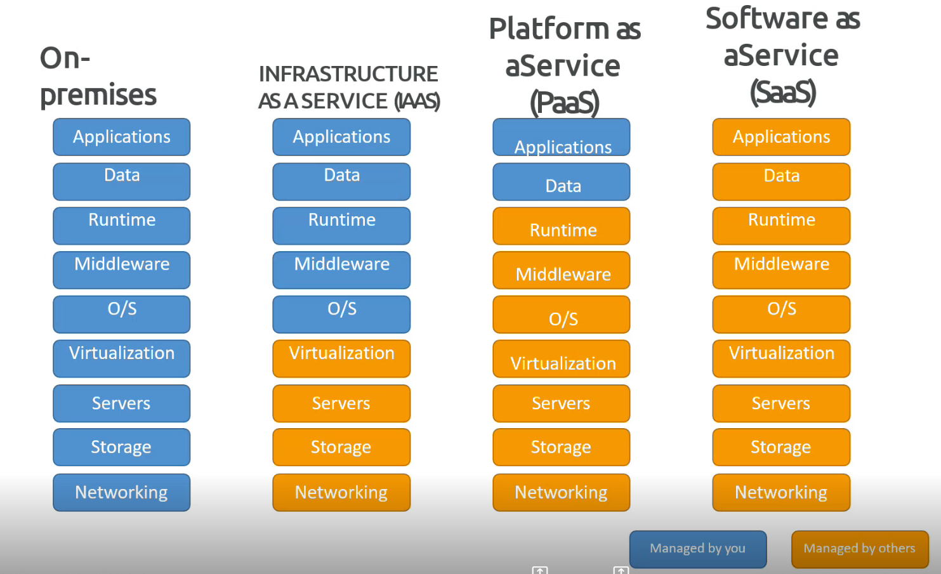

**Module 2: Compute in the Cloud**

* Describe the benefits of Amazon Elastic Compute Cloud (Amazon EC2) at a basic level
* Identify the different Amazon EC2 instance types
* Differentiate between the various billing options for Amazon EC2
* Describe the benefits of Amazon EC2 Auto Scaling
* Summarize the benefits of Elastic Load Balancing
* Give an example of the uses for Elastic Load Balancing
* Summarize the differences between Amazon Simple Notification Service (Amazon SNS) and Amazon Simple Queue Services (Amazon SQS)
* Summarize additional AWS compute options

1. **Amazon EC2?**

* EC2 is one of the most popular of AWS offering
* EC2 is an Infrastructure as a service (Iaas)
* It mainly consists of capability of:
* Renting virtual machines (EC2)
* Storing data on virtual drives (EBS)
* Distributing loads across machines (ELB)
* Scaling the services using an auto-scaling group (ASG)
* 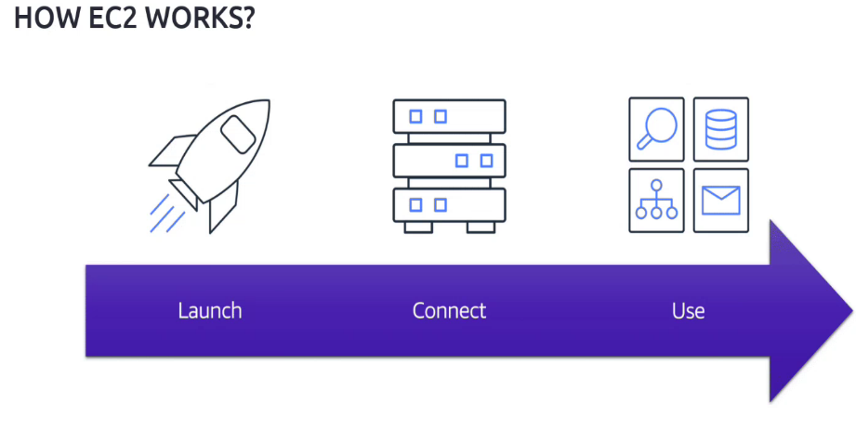Knowing EC2 is fundamental to understand how the cloud works.
* [**https://app.pluralsight.com/hands-on/labs/1b522849-dd33-43e4-90ba-4d10a3319a96 -** Introduction to EC2](https://app.pluralsight.com/hands-on/labs/1b522849-dd33-43e4-90ba-4d10a3319a96%20-%20Introduction%20to%20EC2)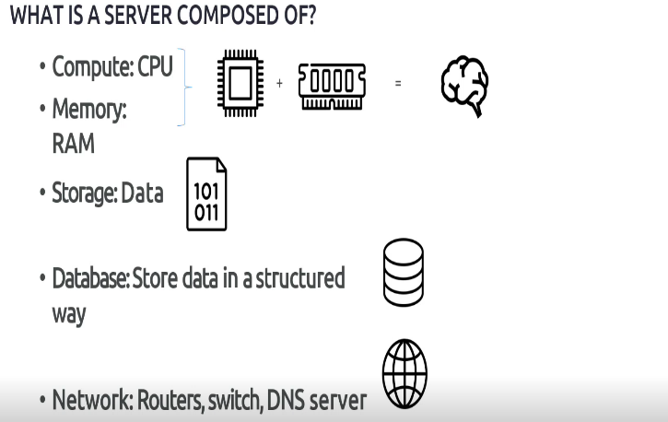

1. **Scalability and High availability?**

* Scalability means that an application/system can handle greater loads by adopting.
* There are two kinds of scalability:
* Vertical scalability
* Horizontal scalability
* Scalability is linked but different to high availability.

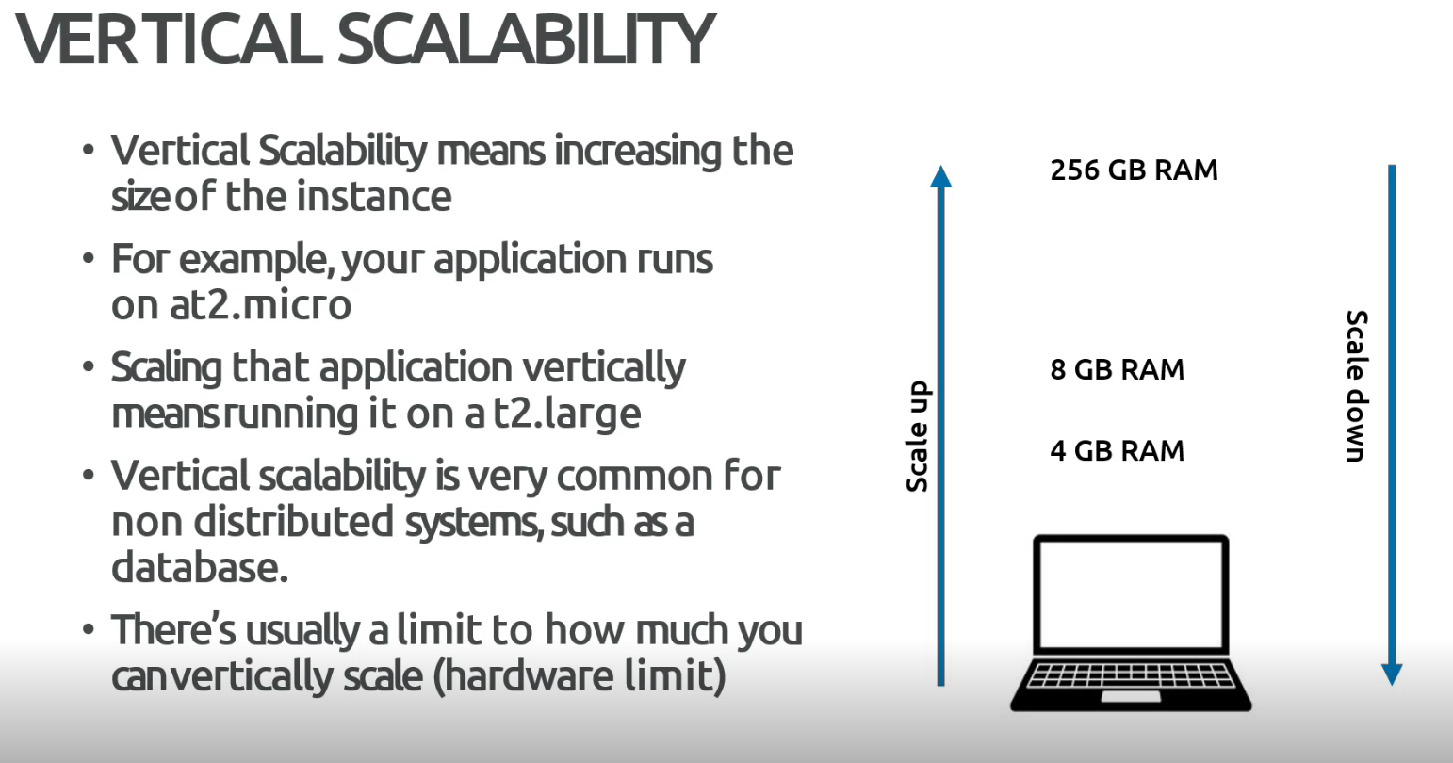

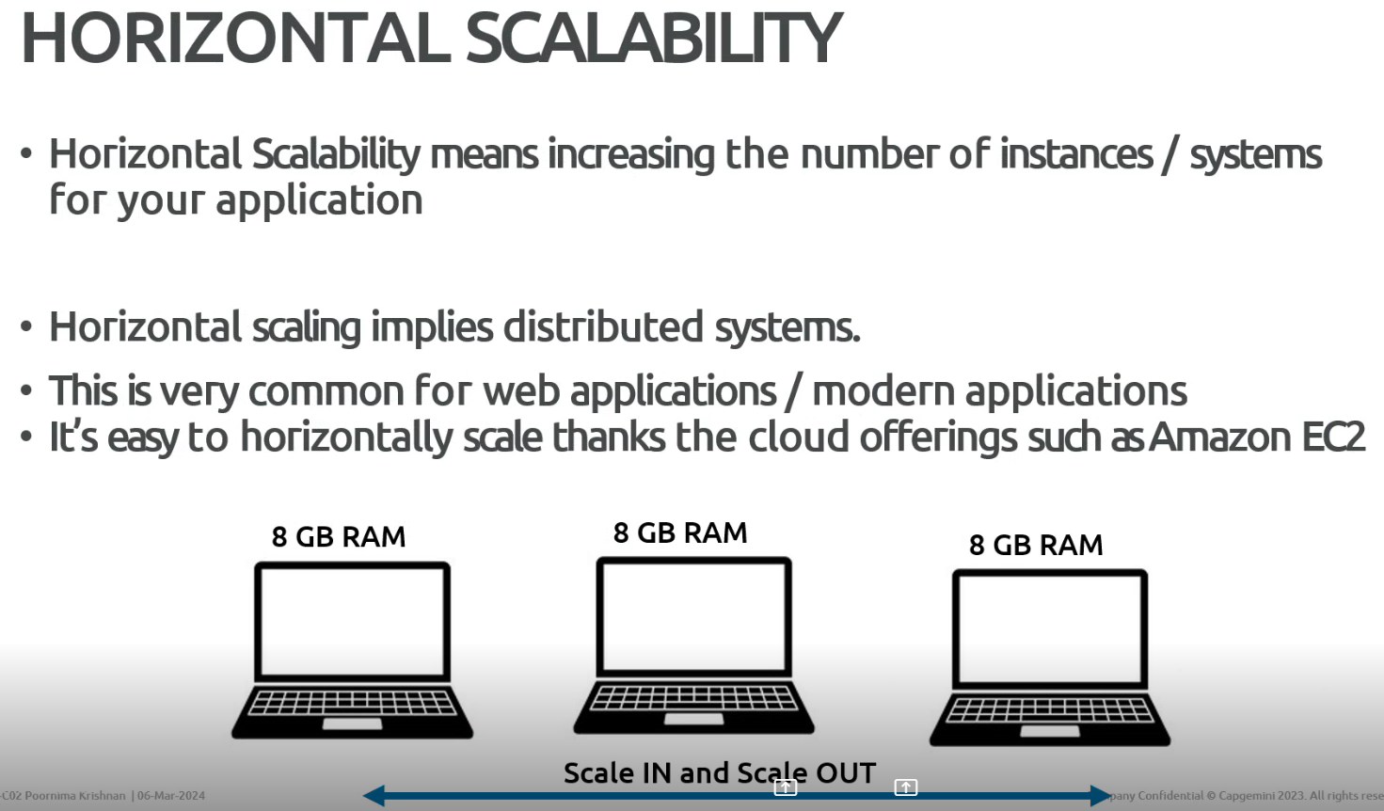

1. **High Availability?**

* High Availability usually goes hand in hand with horizontal scaling.
* High Availability means running our application/system in at least 2 Availability zones.
* The goal of high availability is to survive a data centre loss (disaster)

1. **High availability and scalability for EC2?**

* **Vertical Scaling:** Increase instance size (= scale up/down)
* From: t2.nano – 0.5G of RAM, 1 cCPU
* To: u-12tb1.metal – 12.3 TB of RAM, 448 vCPUs
* **Horizontal Scaling:** Increase number of instances (= scale out/in)
* Auto Scaling Group
* Load Balancer
* **High availability:** Run instances for the same application across multiple availability zone.
* Auto scaling group multi availability zone
* Load balancer multi availability zone.

1. **What’s an auto-scaling group?**

* In real life, the load on our websites and application can change
* In the cloud, we can create and get rid of servers very quickly.
* The goal of an Auto-scaling group (ASG) is to:
* Scale out (add EC2 instances) to match an increased load
* Scale in (remove EC2 instances) to match a decreased load.
* Ensure we have a minimum and maximum numbers of machines running.
* Automatically register new instances to a load balancer.
* Replace unhealthy instances
* Cost Savings: Only run at an optimal capacity (Principle of the cloud)
* <https://app.pluralsight.com/hands-on/labs/101a38bd-8b97-44b0-a52c-9b66b405aff9> - Launching an Autoscaling Group in AWS <https://docs.aws.amazon.com/autoscaling/>

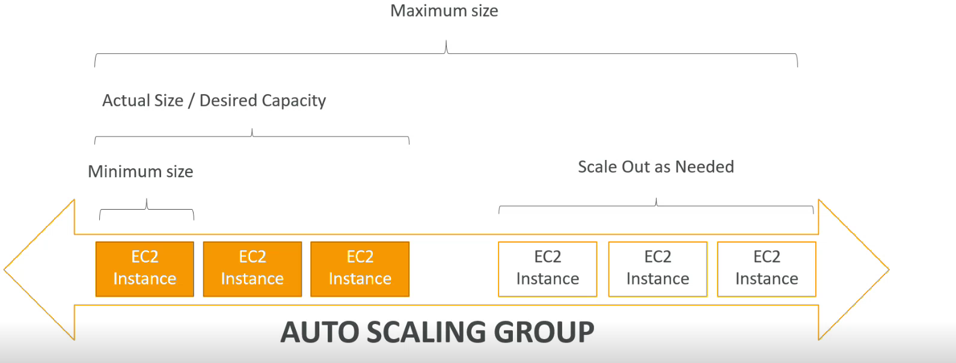

1. **What is load balancing?**

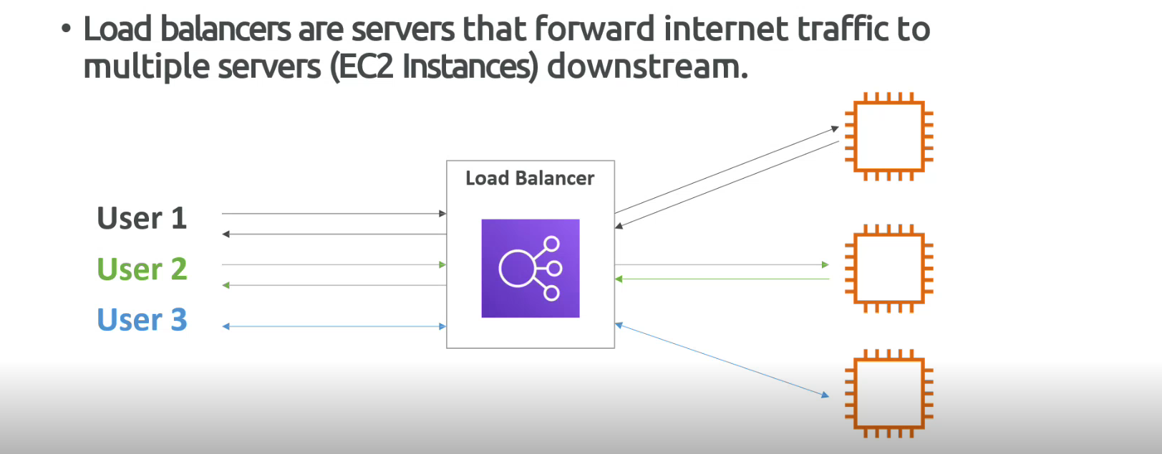

1. **Why use a load balancer?**

* Spread load across multiple downstream instances.
* Expose a single point of access (DNS) to our application
* Seamlessly handle failures of downstream instances
* Do regular health checks to our instances.
* High availability across zones.

1. **Why use an elastic load balancer?**

* An ELB (Elastic load balancer) is a managed load balancer
* AWS guarantees that it will be working.
* AWS takes care of upgrades, maintenance, high availability.
* AWS provides only few configuration knobs.
* It cost less to setup our own load balancer, but it will be lotting more effort on our end (Maintenance and integrations).
* There are four kinds of load balancers offered by AWS:
* Application load balancer (HTTP / HTTPS only) – Layer 7
* Network load balancer (Ultra high performance, allow for TCP) – Layer 4
* Gateway load balancer – Layer 3
* Classic load balancer (retired in 2023) – Layer 4 and 7

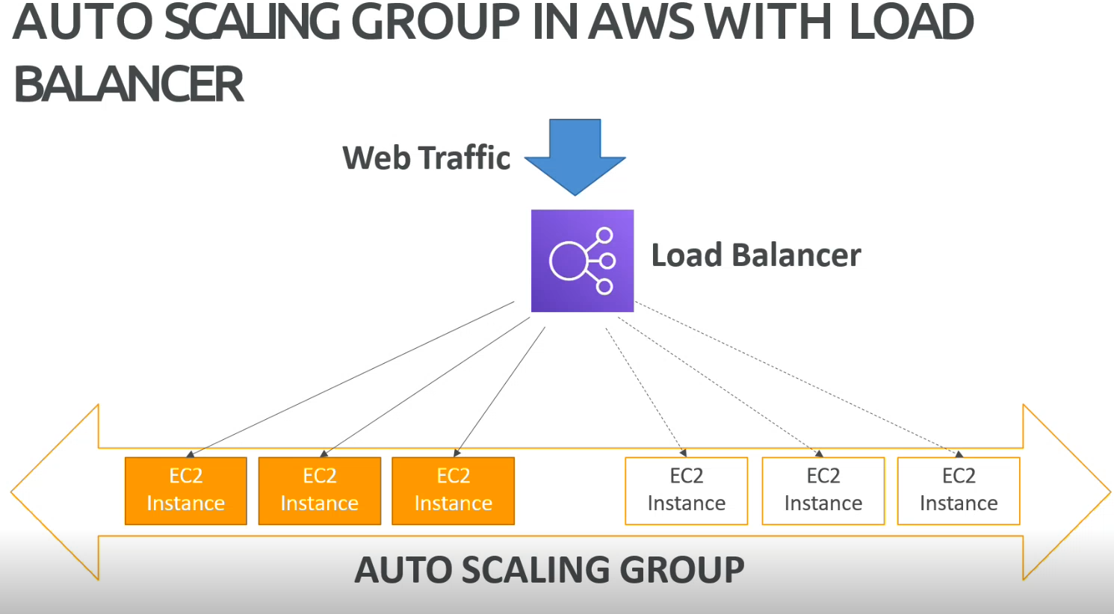

1. **Serverless computing?**

* One of the serverless service that offering AWS is AWS lambda.

**Why AWS lambda?**

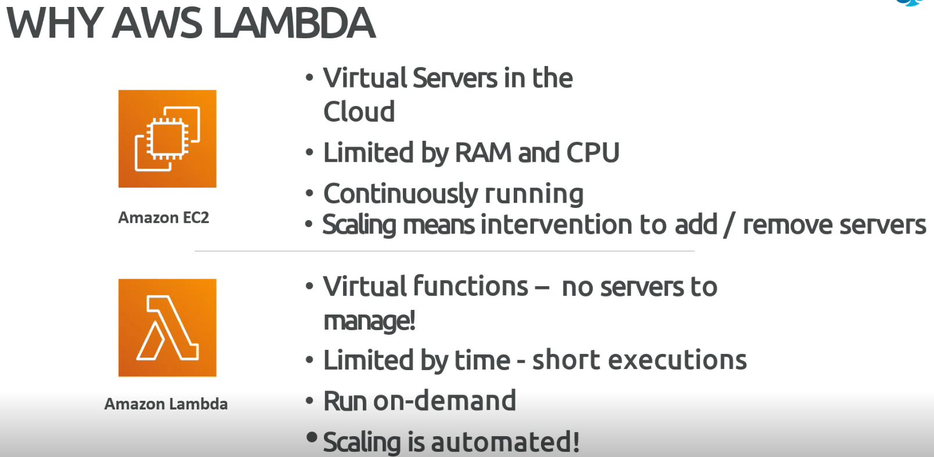

**How AWS lambda Works?**

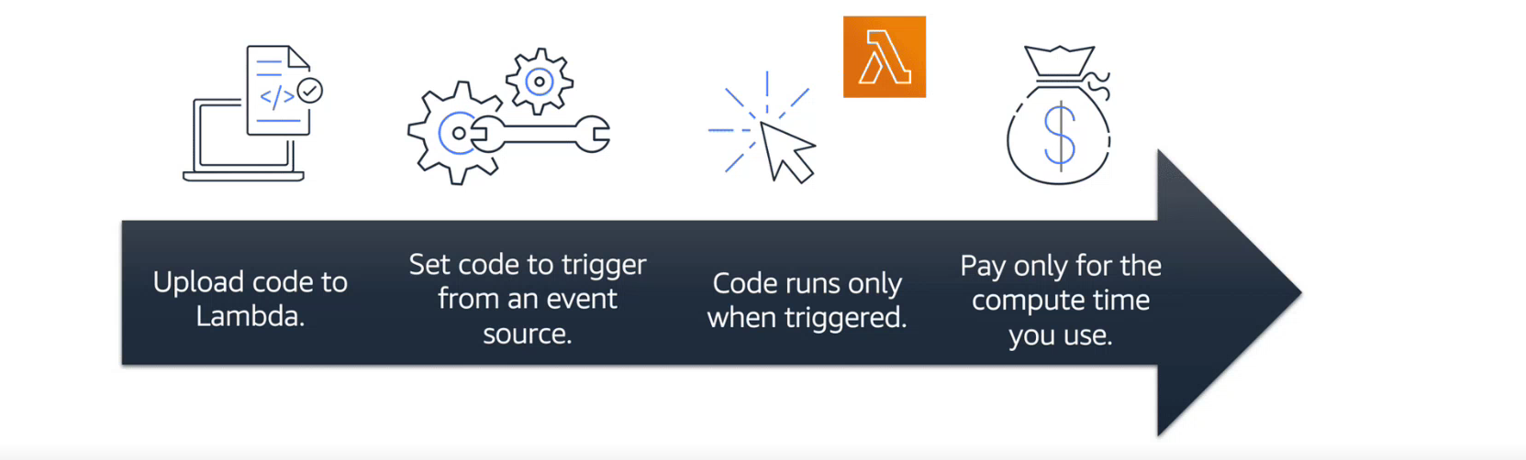

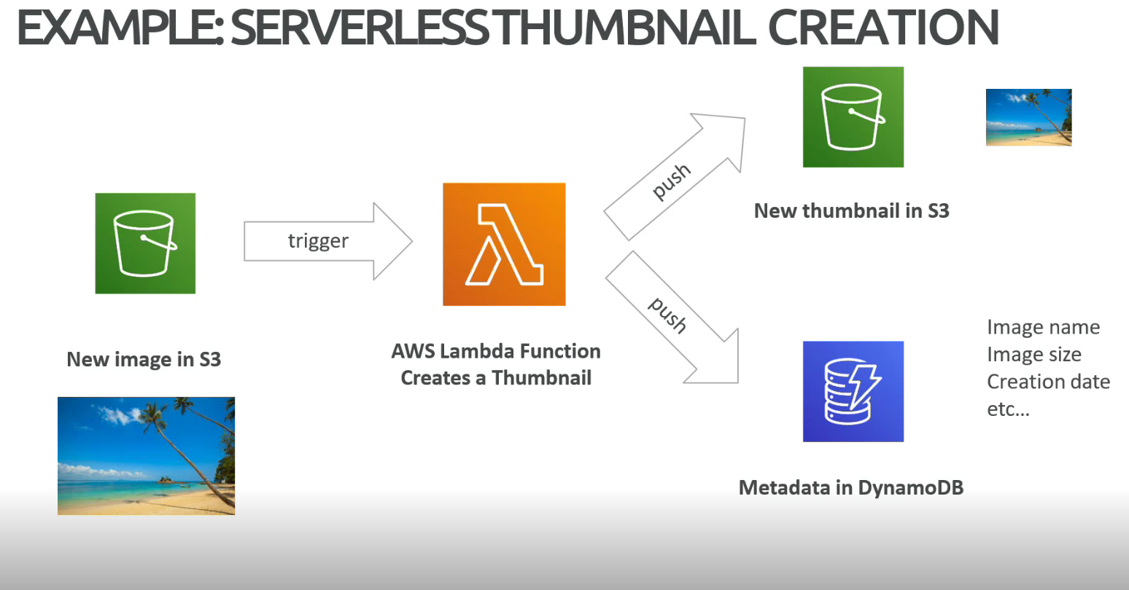

[**https://app.pluralsight.com/hands-on/labs/f2b58b6b-2a05-435a-8746-ca1ff25b9773**](https://app.pluralsight.com/hands-on/labs/f2b58b6b-2a05-435a-8746-ca1ff25b9773) **- Creating a Simple AWS Lambda Function**

1. **Amazon Elastic container Service (Amazon ECS)**

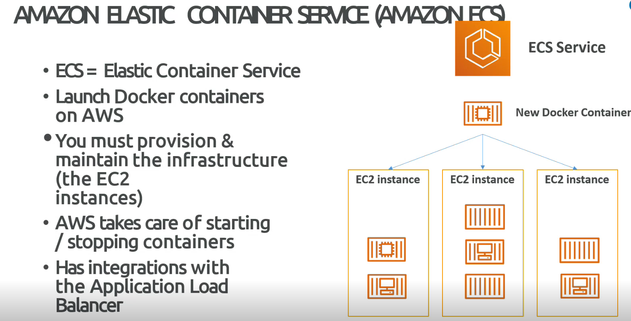

**Module 3: AWS Global Infrastructure and Reliability**

* Summarize the benefits of the AWS Global Infrastructure
* Describe the basic concept of Availability Zones
* Describe the benefits of Amazon CloudFront and Edge locations
* Compare different methods for provisioning AWS services

[**https://aws.amazon.com/about-aws/global-infrastructure/**](https://aws.amazon.com/about-aws/global-infrastructure/)

1. **How to choose an AWS region?**

* **Compliance**: With data governance and legal requirements: data never leaves without our explicit permission.
* **Proximity**: To customers: reduce latency
* **Available services**: Within a region: new services and new features are not available in every region.
* **Pricing**: Pricing varies region to region and is transparent in the service pricing page.

1. **Aws Availability zones?**

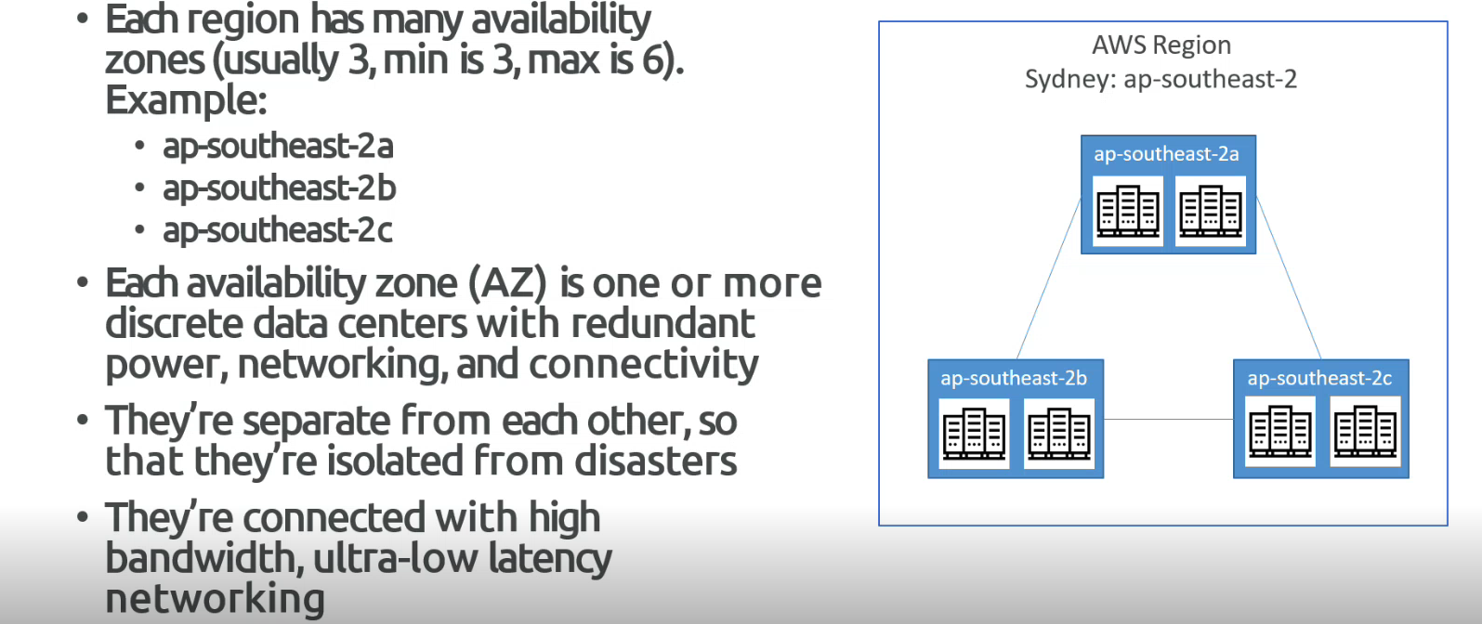

1. **Aws edge location.**

* Amazon has 600+ points of presence (400+ edge locations and 10+ regional caches) in 90+ cities across the 40+ countries.
* 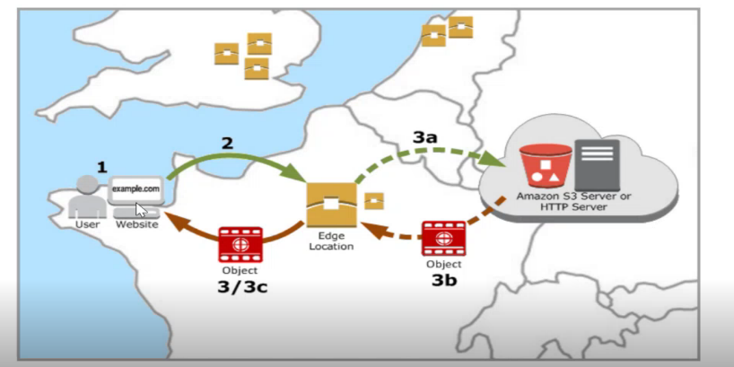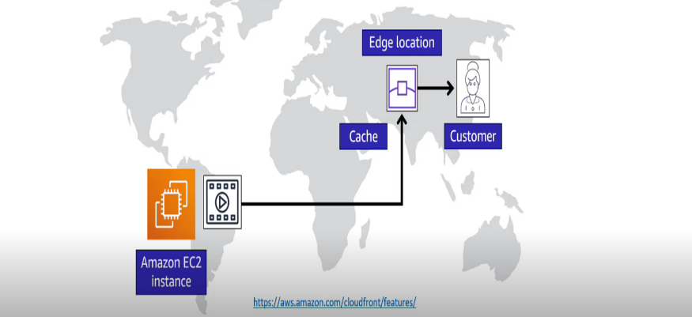Content is delivered to end users with lower latency.

1. **How can users access AWS?**

* To access AWS, we have three options:
* AWS management console (Protected by password + MFA)
* AWS command line interface (CLI): Protected by access keys
* AWS software development kit (SDK) – for code: Protected by access keys.
* **AWS command line interface (CLI)**
* A tool that enables to interact with AWS services using commands in our command-line shell.
* Direct access to the public APIs of AWS services.
* We can develop scripts to manage our resources
* It’s open source <https://github.com/aws/aws-cli>
* Alternative to using AWS management console.
* **AWS software development kit (SDK)**
* It has language specific APIs (Set of libraries)
* Enables to access and manage AWS services programmatically.
* Embedded within our application
* Supports:

(JavaScript, python, PHP, .NET, Ruby, Java, Node.js c++)

Mobile SDKs (Android, IOS, ….)

IoT devices SDKs (Embedded C, Arduino…)

* **Example:** AWS CLI is built on AWS SDK for python.

1. **AWS elastic beanstalk overview**

* Elastic beanstalk is a developer centric view of deploying an application on AWS
* Beanstalk is a platform as a service (Paas)
* Beanstalk is free but pay only for underlying instances.
* Managed services:
* Instance configuration/ OS is handled by beanstalk.
* Deployment strategy is configurable but performed by elastic beanstalk
* Capacity provisioning
* Load balancing and auto-scaling
* Application health-monitoring and responsiveness.
* Just the application code is the responsibility of the developer
* Three architecture models are:
* Single instance deployment: good for dev
* LG + ASG: Grate for production or pre-production wen applications
* ASG only: great for non-web apps in production (workers etc...)

1. **What is cloud formation?**

* CloudFormation is a declarative way of outlining our AWS Infrastructure, for any resources (most of them are supported).
* For example: withing a cloud formation template, you say:
* I want a security group
* I want two EC2 instances using this security group
* I want an S3 bucket
* I want a load balancer (ELB) in front of these machines.
* Then cloud formation creates the above features in the right order, with the exact configuration that we specify.

**Benefits of AWS cloud formation:**

* Infrastructure as a code
* No resources are manually created, which is excellent for control.
* Changes to the infrastructure are reviewed through code.
* Cost
* Each resource within the stack is tagged with an identifier so we can easily see how much a stack costs
* We can estimate the costs of our resources using the CloudFormation template.
* Savings strategy: In dev, we could automation deletion of templates at 5 PM and recreated at 8 PM, safely.
* Productivity
* Ability to destroy and recreate an infrastructure on the cloud fly.
* Automated generation of diagram for our templates.
* Declarative programs (no need to figure out ordering and orchestration)
* Don’t re-invent the wheel
* Leverage existing templates on the web.
* Leverage the documentation
* Supports (almost) all Aws resources
* We can use “Custom resources” for resources that are not supported.

**Module 4: Networking**

* Describe the basic concepts of networking
* Describe the difference between public and private networking resources
* Explain a virtual private gateway using a real-life scenario
* Explain a virtual private network (VPN) using a real-life scenario
* Describe the benefit of AWS Direct Connect
* Describe the benefit of hybrid deployments
* Describe the layers of security used in an IT strategy
* Describe which services are used to interact with the AWS global network

1. **Amazon VPC:**

* A VPC, or virtual private cloud, is essentially our own private network in AWS.
* A VPC allows to define our IP range for our AWS resources, and we place things like EC2 instances and ELBs inside our VPC.
* Amazon VPC enables to provision an isolated section of the AWS cloud. In this isolated section we can launch resources into subnets. A subnet is section of a VPC that can contain resources such as Amazon EC2 instances.

1. **Subnets and NACL**

A subnet is a section of a VPC in which we can group resources based on security or operational needs. Subnets can be public or private.

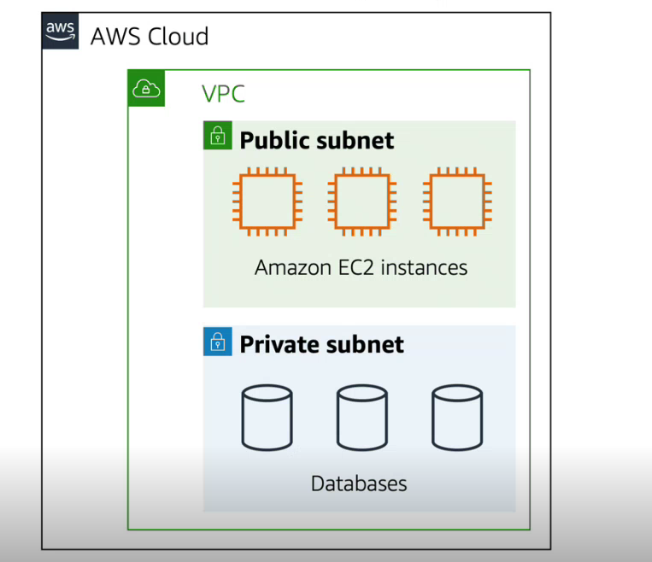

1. **Internet gateway**

* To allow public traffic from the internet to access our VPC, we attach an internet gateway to the VPC.

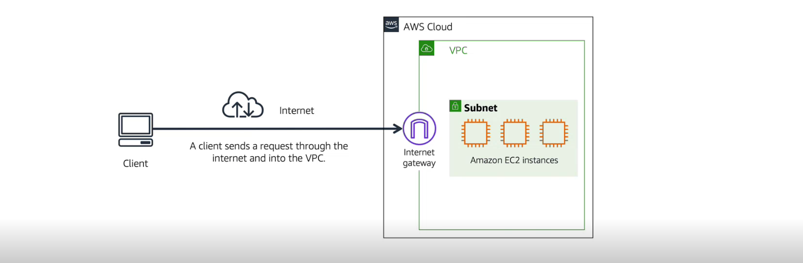

1. **Virtual private gateway**

* To access private resources in a VPC, we can use a virtual private gateway.

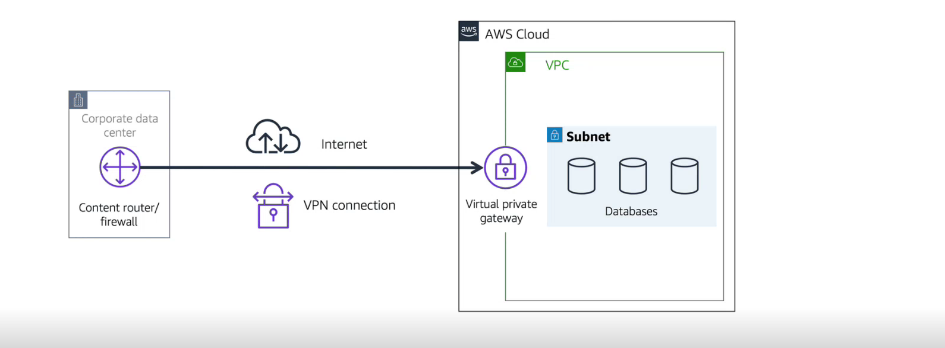

1. **AWS Direct connect**

* It is a service that establish a dedicated private connection between our data centre and a VPC.

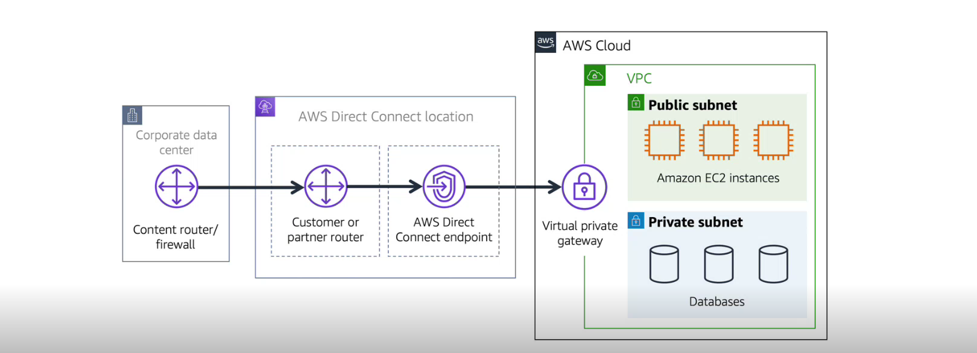

1. **NACL (Network access control list)**

* A network ACL is a virtual firewall that controls inbound and outbound traffics at the subnet level.
* Network ACLs perform stateless packet filtering. They remember nothing and check packets that cross the subnet border each way: inbound and outbound.

1. **Security groups**

* It is virtual firewall that controls inbound and outbound for an Amazon EC2 instance.
* Security groups perform stateful packet filtering. They remember previous decisions made for incoming pockets.

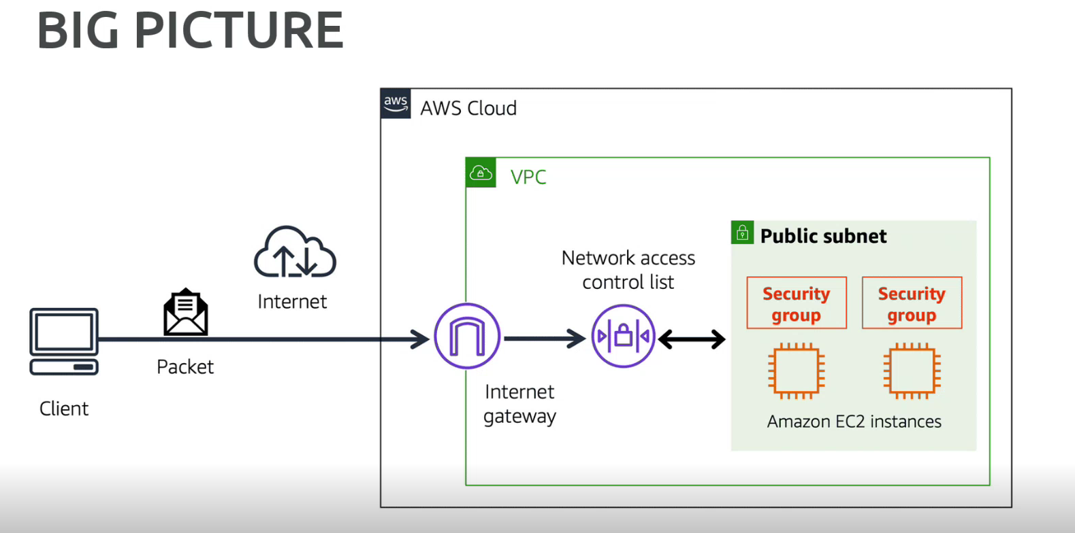

<https://app.pluralsight.com/hands-on/labs/2cc3cf9e-61ce-475d-a00e-03306e9ba285> - Creating a Basic VPC and Associated Components in AWS

<https://app.pluralsight.com/hands-on/labs/c30ef1d8-6dff-434d-a484-698027c13d53> - Configuring a Basic VPC in AWS

1. **Global Networking – DNS (Domain name system):**

* DNS resolution involves a customer DNS resolver communicating with the company DNS server
* We can think of DNS as being a phone book of the internet. DNS resolution is the process of translating a domain name to an IP address.



1. **Global Networking – Amazon route 53**

* Amazon route 53 is a DNS web service. It gives developers and businesses a reliable way to route end users to internet applications hosted in AWS.
* It connects user requests to infrastructure running in AWS (Such as Amazon EC2 instances and load balancers). It can route users to infrastructure outside of AWS.

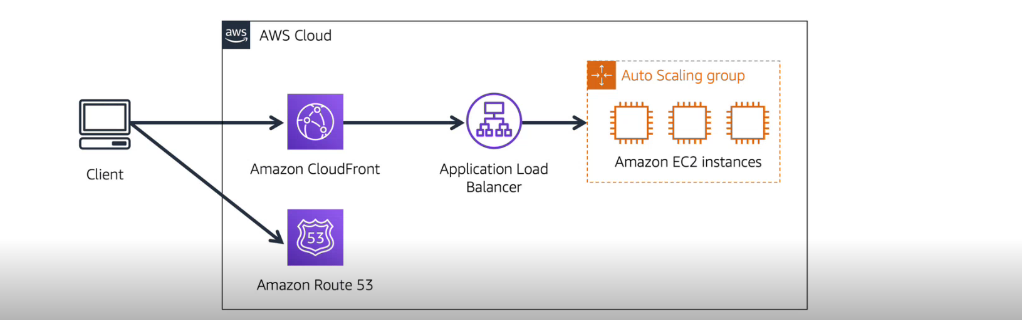

**Module 5: Storage and Databases**

* Summarize the basic concept of storage and databases
* Describe benefits of Amazon Elastic Block Store (Amazon EBS)
* Describe benefits of Amazon Simple Storage Service (Amazon S3)
* Describe the benefits of Amazon Elastic File System (Amazon EFS)
* Summarize various storage solutions
* Describe the benefits of Amazon Relational Database Service (Amazon RDS)
* Describe the benefits of Amazon DynamoDB
* Summarize various database services

1. **Instance Stores**

* An instance stores provides temporary block-level storage for an EC2 instance.
* An instance store is disk storage that is physically attached to the host computer for an EC2 instance, and therefore has the same lifespan as the instance.
* When the instance is terminated, we loss any data in the instance store.

1. **Amazon EBS (Elastic block storage)**

* Amazon EBS is a service that provides block-level storage volumes that we can use with amazon EC2 instances.
* If we stop or terminate an Amazon EC2 instance, all the data on the attached EBS volume remains available.
* Block-level storage volumes behave like physical hard drives.

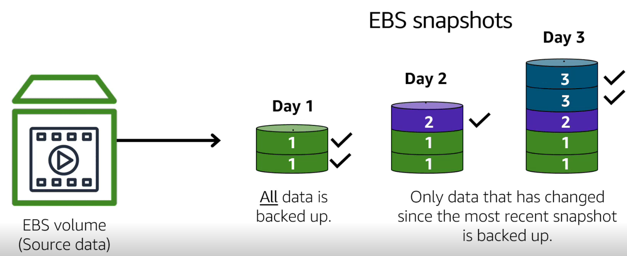

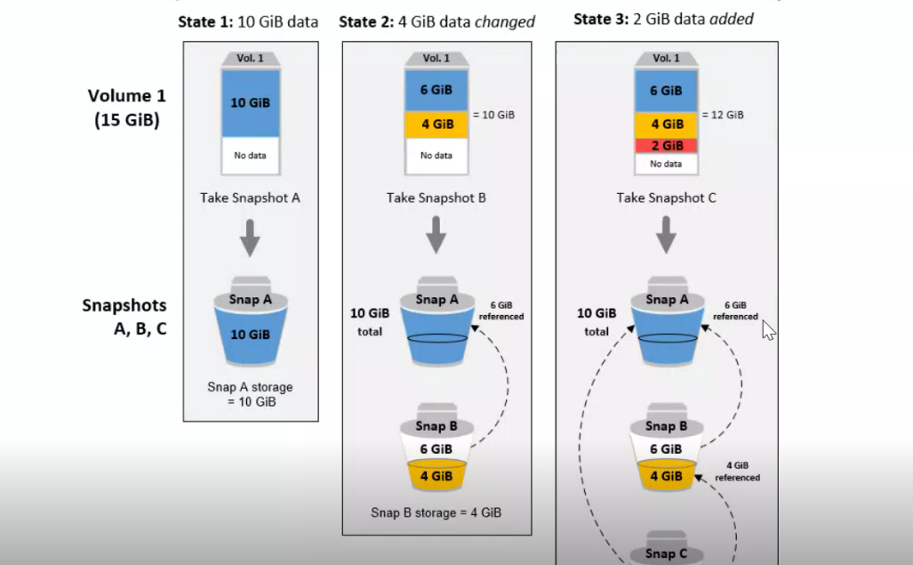

1. **File storage**

* In file storage, multiple clients (such as users, applications, servers, and so on) can access data that is stored in shared file folders.
* In this approach, a storage server uses block storage with a local file system to organize files. Clients access data through file paths.
* File storage is ideal for use cases in which many services and resources need to access the same data at the same time.

1. **AWS EFS (Elastic file system)**

* Amazon EFS is a scalable file system used with AWS cloud services and on-premises resources
* As we add and remove files, Amazon EFS grows and shrinks automatically. It can scale on-demand to petabytes without disrupting applications.
* Amazon EFS is regional service. It stores data in and across multiple availability zones.

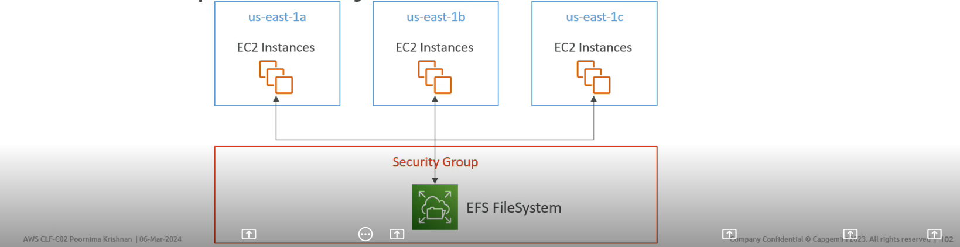

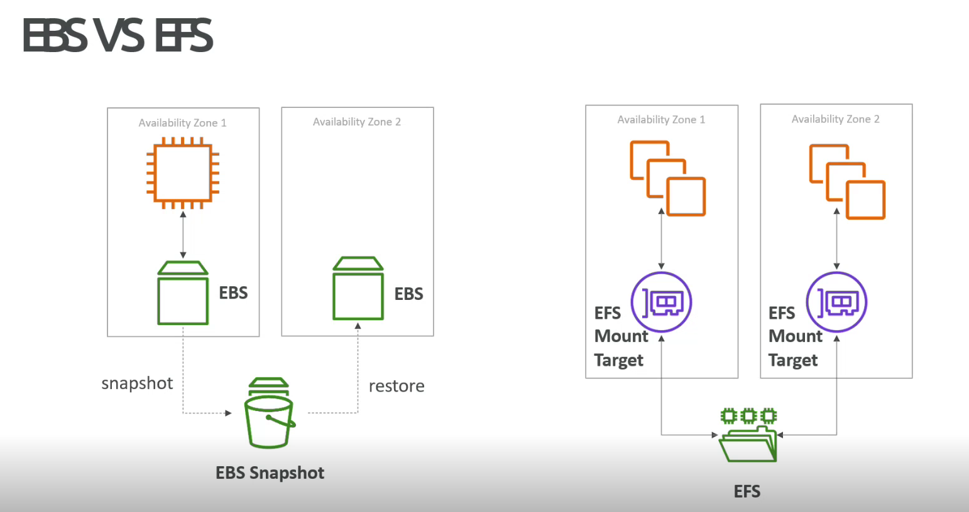

1. **Object storage**

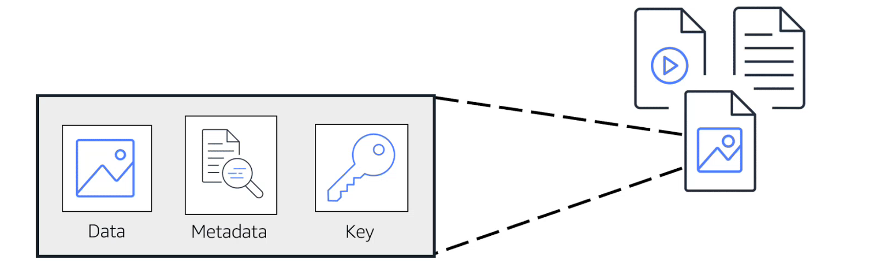

1. **Amazon S3 bucket**

* Amazon simple storage service (S3 bucket) is a service that provides object-level storage.
* Amazon S3 stores data as objects in buckets.
* We can upload any type of file to Amazon S3, such as images, videos text files, and so on.
* When we upload a file to Amazon S3, we can set permissions to control visibility and access to it.
* We can also use Amazon S3 versioning features to track changes to our objects over time.

1. **Amazon S3 storage classes**

* With Amazon S3, we pay only for what we use. We can choose from a range of storage classes to select a fit for our business and cost needs. When selecting an Amazon S3 storage class, consider these two factors:
* How often we plan to retrieve our data?
* How available we need our data to be?

<https://aws.amazon.com/s3/storage-classes/?nc=sn&loc=3>

1. **Amazon RDS (Relational database service)**

* Amazon RDS is a service that enables to run relational database in the AWS cloud.
* Amazon RDS is a managed service that automates takes such as hardware provisioning, database setup, patching, and backups.
* We can integrate Amazon RDS with other services to fulfil our business and operational needs, such as using AWS lambda to query our database from a serverless application.

1. **Amazon RDS database engines**

* **Amazon aurora** – Amazon Aurora in AWS is a high-performance, scalable, and fully managed relational database service compatible with MySQL and PostgreSQL.
* **PostgreSQL** - PostgreSQL is a powerful, open-source relational database management system known for its advanced features, extensibility, and support for both SQL and NoSQL data models.
* **MySQL** - Amazon RDS for MySQL is a fully managed relational database service provided by AWS that makes it easy to set up, operate, and scale a MySQL database in the cloud.
* **MariaDB** - MariaDB is an open-source relational database management system (RDBMS) that is a fork of MySQL.
* **Oracle Database** – It is a relational database management system (RDBMS) developed by **Oracle Corporation**. It is one of the most popular, widely used, and comprehensive database solutions available for enterprises and organizations.
* **Microsoft SQL Server** – It is a powerful, reliable, and feature-rich relational database management system used in a wide variety of enterprise applications.

It offers high availability, scalability, security, and performance, making it suitable for transactional systems, data warehousing, business intelligence, and more.

1. **Non-relational database**

* In a non-relational database, we create tables.
* Non-relational database is sometimes referred to as “NoSQL database” because they use structures other than rows and columns to organize data.
* One type of structural approach for nonrelational database is key-value pairs. With key-value pairs, data is organized into items (keys), and items have attributes (Values).
* We can think of attributes as being different features of our data.

1. **Amazon Dynamo Db**

* It is a key-value pair database service. It delivers single digit millisecond performance at any scale.
* DynamoDB is serverless
* Automatic scaling

**Additional Database Services:**

* **Amazon Redshift** – It is a data warehousing service that we can use for big data analytics. It offers the ability to collect data from many sources and helps to understand relationships and trends across our data.
* **Amazon Document DB** - It is a document database service that supports MongoDB workloads.
* **Amazon Neptune** – It is a graph database service.
* **Amazon Quantum Ledger Database (Amazon QLDB)** – It is a ledger database service.
* **Amazon managed blockchain**
* **Amazon Elastic Cache**
* **Amazon DynamoDB Accelerator (Dax)** – It is an in-memory cache for DynamoDB.

**AWS Database Migration Service (AWS DMS)** – It enables us to migrate relational database, non-relation database and other types of data stores.

**Module 6: Security**

* Explain the benefits of the shared responsibility model
* Describe multi-factor authentication (MFA)
* Differentiate between the AWS Identity and Access Management (IAM) security levels
* Describe security policies at a basic level
* Explain the benefits of AWS Organizations
* Summarize the benefits of compliance with AWS
* Explain primary AWS security services at a basic level

1. **AWS shared responsibility model**

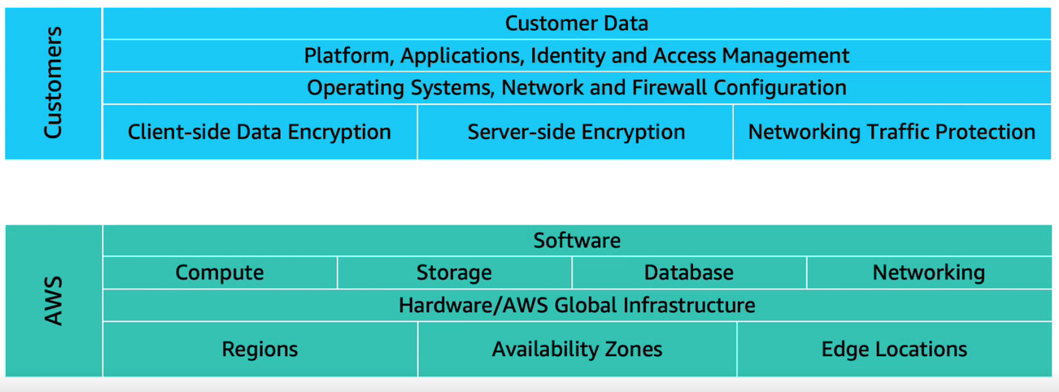

**Shared Responsibilities model for EC2**

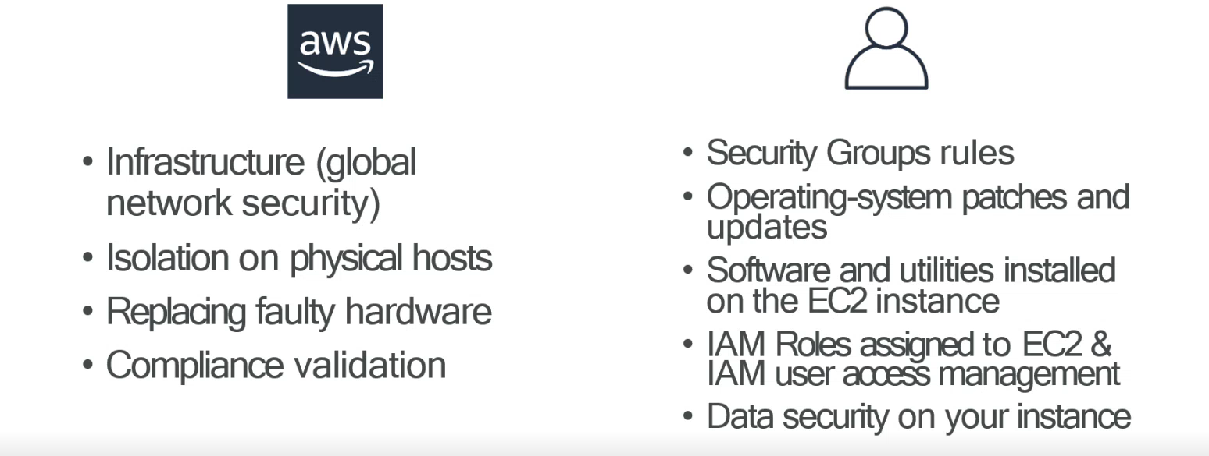

**Shared Responsibilities Model for S3**

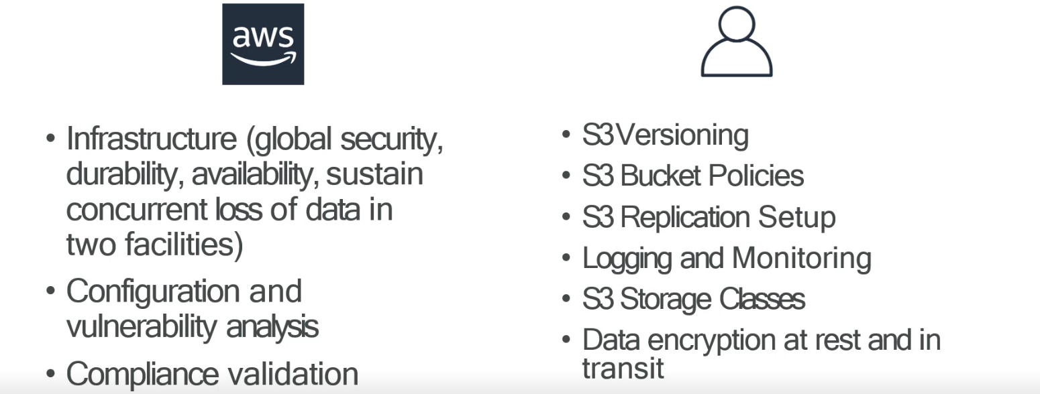

1. **AWS Identity and access management (IAM)**

* IAM enables to manage access to AWS services and resources securely.
* IAM gives the flexibility to configure access on company’s specific operational and security needs.
* IAM users, groups and roles.
* IAM policies
* Multi-factor authentication.

1. **AWS Account root user**

* When we create first AWS account, we begin with an identity known as the root user
* The root user is accessed by signing in with the email address and password that we used to create our Aws account.
* It has complete access to all the Aws services and resources in the account.
* Do not use the root user for everyday task. Instead, use the root user to create our first IAM user and assigns it permissions to create other users.
* Continue to create other IAM users, and access those identities for performing regular tasks throughout the AWS
* Only use root user when we need to perform a limited number of tasks that are only available to the root user.
* Examples of these tasks include changing our root user email address and changing our Aws support plan.

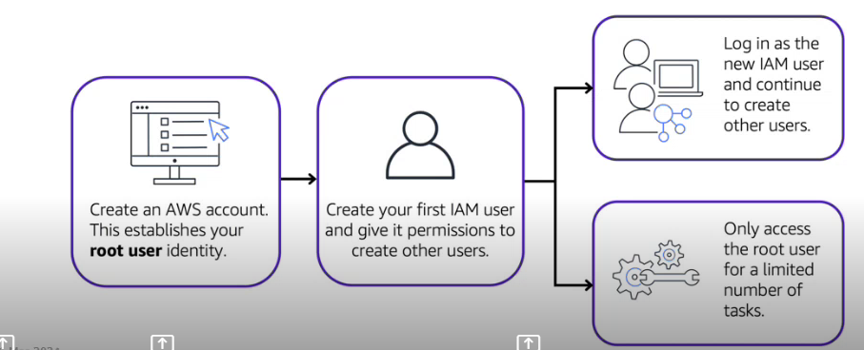

**IAM users**

* An IAM users is an identity that we create in AWS.
* It represents the person or application that interacts with AWS services and resources.
* It consists of name and credentials
* By default, when we create a new IAM user in AWS, it has no permission associated with it.
* To allow the IAM user to perform specific actions in AWS, such as launching an EC2 instance or creating an Amazon S3 bucket, we must grant the IAM user the necessary permissions.
* Create individual IAM users for each person who needs to access AWS.
* Even if we have multiple employees who require the same level of access, we should create individual IAM users for each of them. This provides additional security by allowing each IAM user to have unique set of security credentials.

**IAM Policies**

* An IAM policy is a document that allows or denies permissions to AWS services and resources.
* IAM policies enable to customize user’s levels of access to resources.
* For example, we can allow users to access all the Amazon S3 buckets within our Aws account, or only a specific bucket.
* Follow the security principle of least privilege when granting permissions. By following this principle, we help private users or roles from having more permissions then needed to perform their tasks.
* For example, if an employee needs to access only specific bucket. Specify the bucket in the IAM policy. Do this instead of granting the employee access to all the buckets in our AWS account.

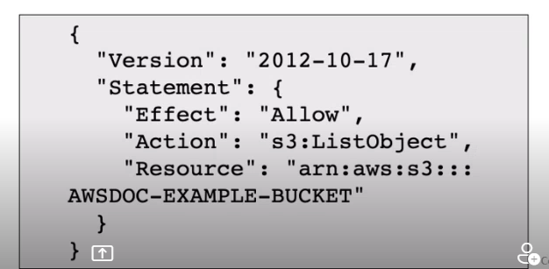

**IAM groups**

* An IAM group is a collection IAM users.
* When you assign an IAM policy to a group, all users in the group are granted permissions specified by the policy.
* Assigning IAM policies at the group level also makes it easier to adjust permissions when an employee transfer to as different job.

**IAM Roles**

* An IAM role is an identity that we can assume to gain temporary access to permissions.
* Before IAM user, application, or service can assume an IAM role, they must be granted permissions to switch to the role.
* When someone assumes an IAM role, they abandon all previous permissions that they add under a previous role and assume the permissions of the new role.
* IAM roles are ideal for situation in which access to services or resources needs to be granted temporarily, instead of long-term.

**Multi-Factor Authentication**

* In IAM, multi-factor authentication (MFA) provides an extra layer of security for our AWS account.
* Requires a second authentication factor in addition to username and password sign-in credentials. We can enable MFA at the AWS account level for root and IAM users we have created in our account.
* With MFA enabled, when a user signs into AWS management console, they are promoted for their user name and password – something they know – and an authentication code from their MFA device – Something they have (or if they use a biometric-enabled authenticator, something they are).
* Taken together, these factors improve security for AWS accounts and resources.
* Available MFA methods for IAM are:
* FIDO security keys
* Virtual authenticator app
* Hardware TOTP token
* Hardware TOTP tokens for the AWS GovCloud (US) Regions

1. **AWS organizations**

* Use AWS organizations to consolidate and manage multiple AWS accounts within a central location
* When we create an organization, AWS organizations automatically create a root, which is the parent container for all the accounts in our organizations.

In AWS organization, we can centrally control permissions for the accounts in our organizations by using service control policies (SCPs). It enables to place restrictions on the AWS services, resources, and individual API actions that users and roles in each account can access.

* Consolidate billing is another feature of Aws organizations.

**Organizational units**

* In AWS organizations, we can group accounts into organizational units (Ous) to make it easier to manage accounts with similar business of security requirements.
* When we apply a policy to an OU, all the accounts in the OU automatically inherit the permissions specified in the policy.
* By organizing separate accounts into Ous, we can more easily isolate workloads or application that have specific security requirements.
* For instance, if our company has accounted that access only the Aws services that meet certain regulatory requirements, we can put this account into one OU. Then, we can attach a policy to the OU that blocks access to all other AWS services that do not meet the regularity requirements.

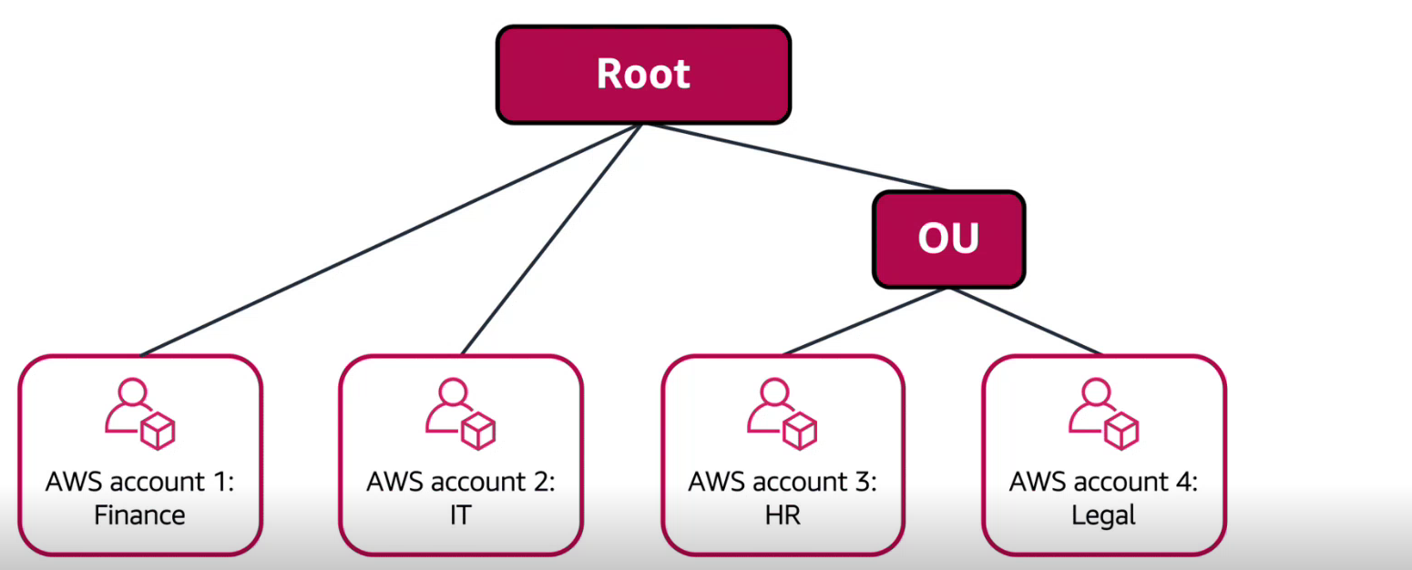

1. **Denial-of-service attacks**

* A denial-of-services attacks (DoS) is a deliberate attempt to make a website or application unavailable to users.
* For example, an attacker might flood a website or application excessive network traffic until the targeted website or application becomes overloaded and is no longer able to respond. If the website or applications becomes unavailable, this denies service to users who are trying to make legitimate requirements.

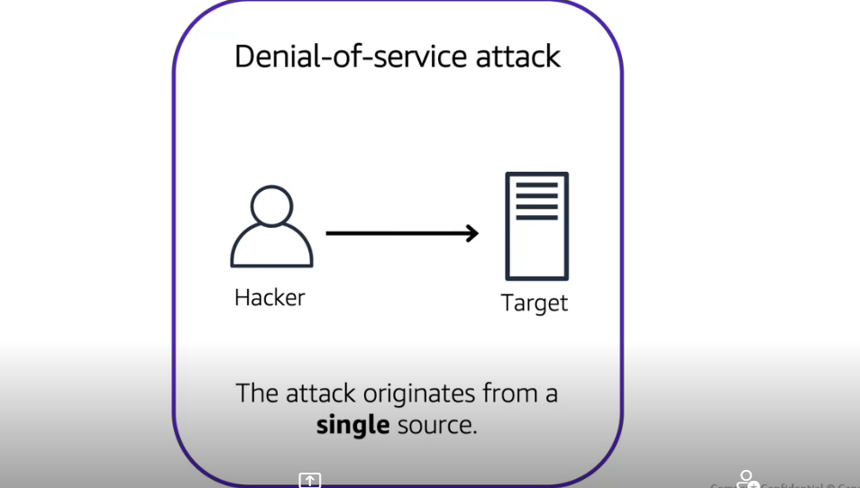

1. **Distributed denial-of-service attacks**

* In a distributed denial-of-service attack, multiple sources are used to start an attack that aims to make a website or application unavailable.
* This can come from a group of attackers, or even a single attacker. The single attacker can use the multiple infected computers (also known as “bots”) to send excessive traffic to a website or application.

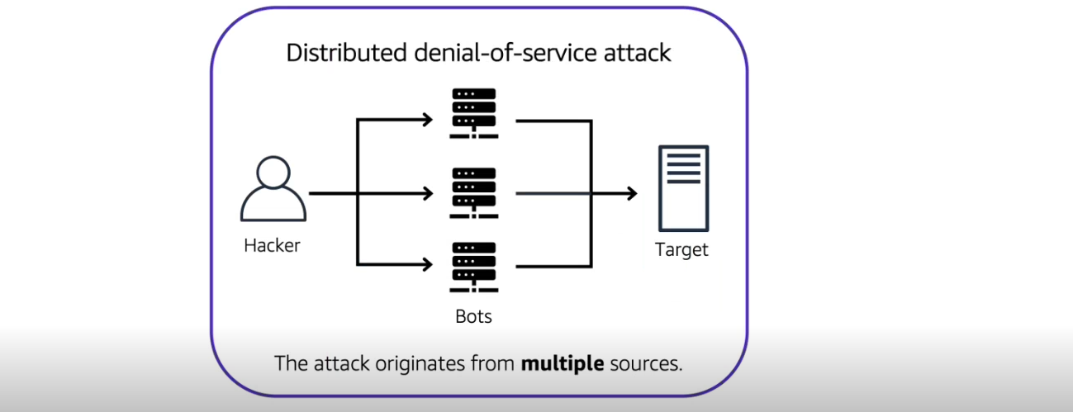

1. **AWS Shield**

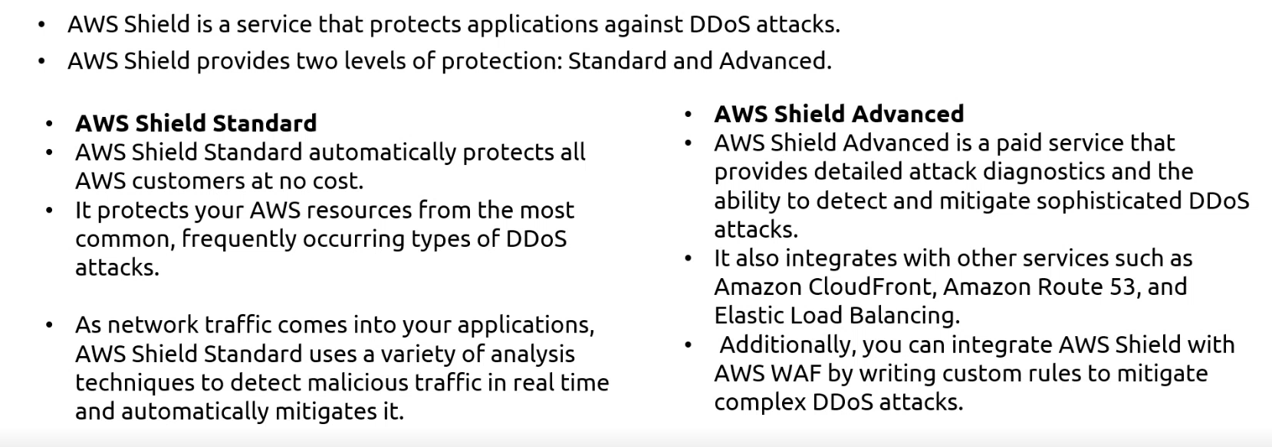

1. **AWS key management service (AWS KMS)**

* AWS key management service (AWS KMS) enables to perform encryption operations using cryptographic keys.
* A cryptographic key is a random string of digits used for locking (encrypting) and unlocking (decrypting) data
* We can use AWS KMS to create, manage and use cryptographic keys.
* We can also control the use of keys across a wide range of services and in our applications.
* With AWS KMS, we can choose the specific levels of access control that we need for our keys.
* For example, we can specify which IAM users and roles are able to manage keys. Alternatively, we can temporarily disable keys so that they are no longer in use by anyone.
* Our keys never leave AWS KMS, and we are always control of them.

1. **AWS WAF**

* AWS WAF is an application firewall that lets monitor network requests that come into our web applications.
* AWS WAF works together with Amazon CloudFront and an application load balancer.
* AWS WAF works for using a web access control list (ACL) to protect our AWS resources.

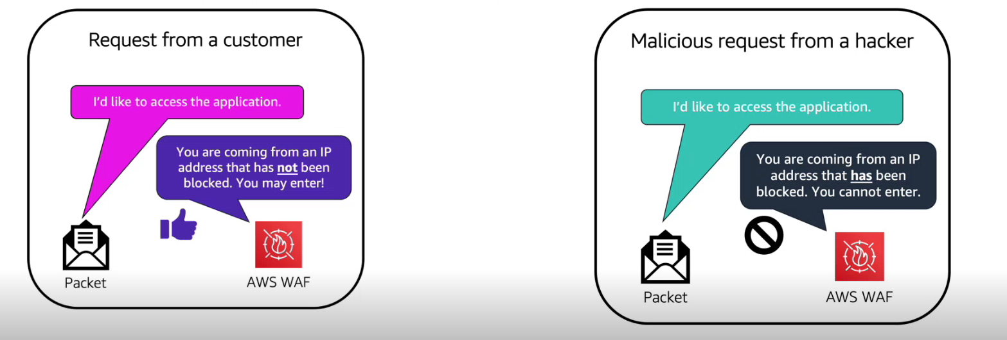

1. **Amazon inspector**

* It helps to improve the security and compliance of applications by running automated security assignments.
* It checks applications for security vulnerabilities and deviations from security best practices, such as open access to Amazon EC2 instances and installations of vulnerable software versions.
* After amazon inspector performed an assignment, it provides with list of security findings.
* The list prioritizes by security level, including a detailed description of each security issues and a recommendation of a how to fix it.
* However, AWS does not guarantee that following the provided recommendations resolves every potential security issue. Under the shared responsibility model, customers are responsible for the security of their applications, processes, and tools that run on AWS services.

1. **Amazon guard duty**

* Amazon guard duty is a service that provides intelligent threat detection for our AWS infrastructure and resources. It identifies threat detection for our AWS infrastructure and resources. It identifies threats by continuously monitoring the network activity and account behaviour within our AWS environment.

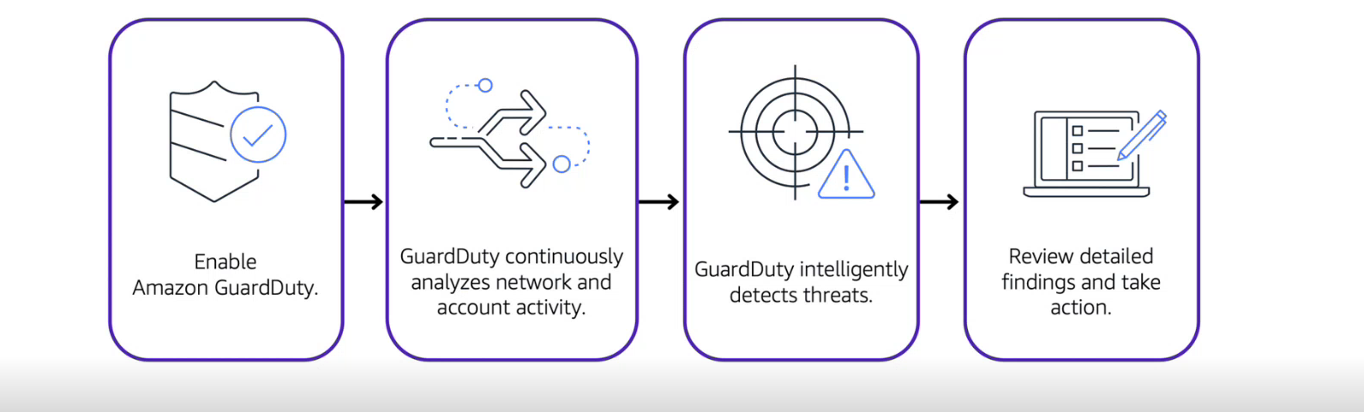

1. **AWS Shield**

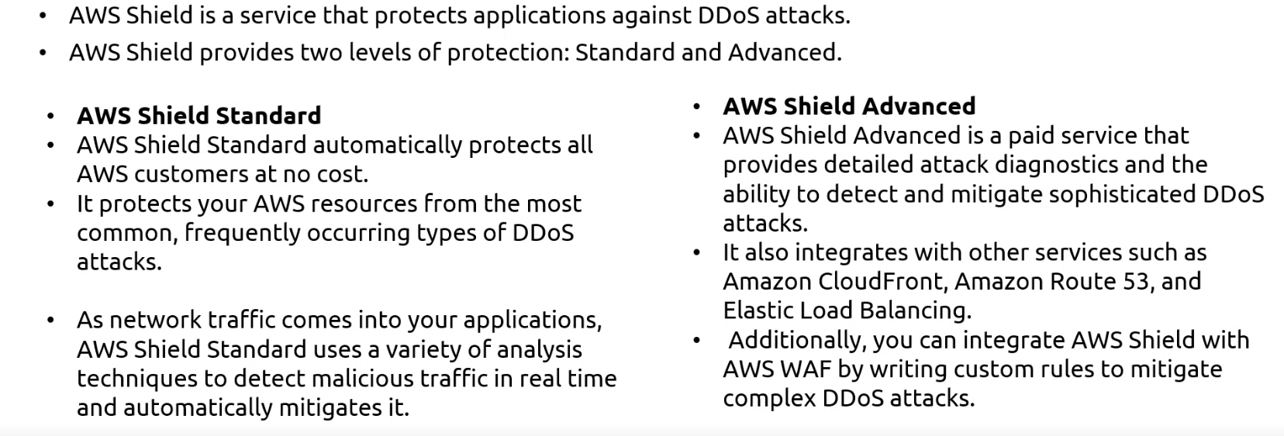

1. **Customer compliance centre**

* It contains resources to help learn more about AWS compliance
* In the customer compliance centre, we can read customer compliance stories to discover how companies in regulated industries have solved various compliance, governance and challenges.
* We can also access compliance white papers and documentations
* AWs answers to key compliance questions
* An overview of AWS risk and compliance
* An auditing security checklist
* The customer compliance centre includes an auditor learning path. This learning path is designed for individuals in auditing, compliance and legal roles who want to learn more about how their internal operations can demonstrate compliance using the AWS cloud.

1. **AWS Artifact**

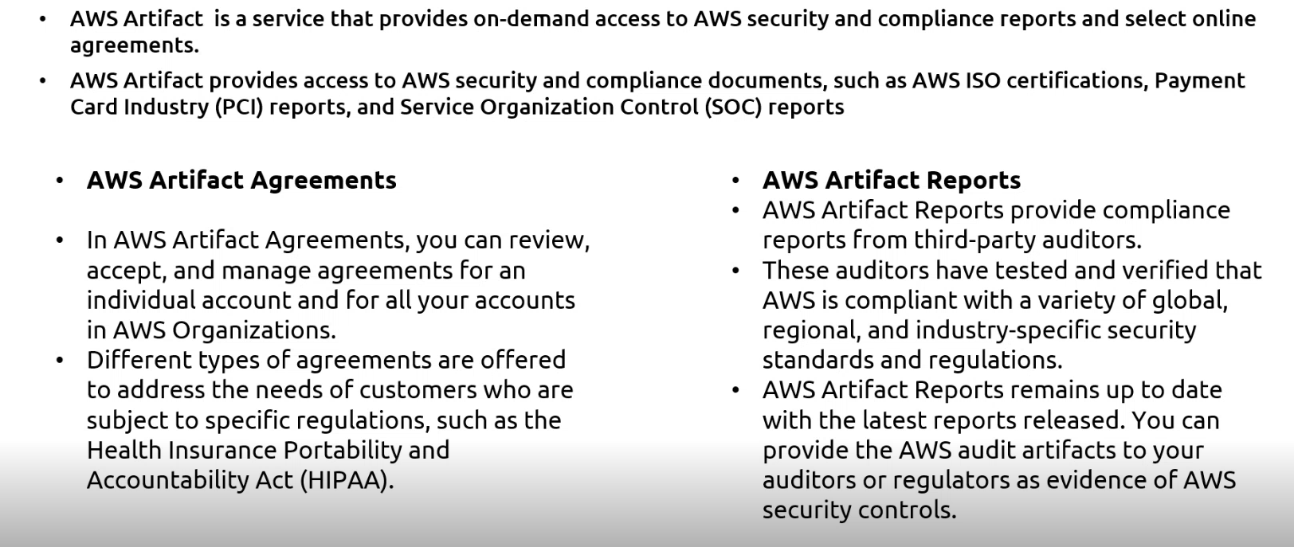

**Module 7: Monitoring and Analytics**

* Summarize approaches to monitoring your AWS environment
* Describe the benefits of Amazon CloudWatch
* Describe the benefits of AWS CloudTrail
* Describe the benefits of AWS Trusted Advisor

1. **Amazon CloudWatch**

* Amazon CloudWatch is a web service that enables to monitor and manage various metrics and configure alarm actions based on data from those metrics.
* CloudWatch uses metrics to represent the data points for our resources. AWS services send metrics to cloud watch. CloudWatch then uses metrics to create graphs automatically that show how performance has changed over time.
* Metrics are data about the performance of our systems
* Metrics are grouped first by namespace, and then by the various dimensions’ combinations withing each namespace. For example, we can view all EC2 metrics, EC2 metrics grouped by instance, or EC2 metrics grouped by auto-scaling group.
* By default, many services provide free service for resources (Such as Amazon EC2 instance, Amazon EBS volumes and Amazon RDS DB instances) we can also enable detailed monitoring for some resources, such as our Amazon EC2 instance, or publish our own application metrics. Amazon CloudWatch can load all the metrics in our account (both Aws resources metrics and application metrics that we provide) for search, graphing, and alarms.
* Metrics data are kept for 15 months, enabling to view both up-to-the minute data and historical data.

1. **CloudWatch Alarms**

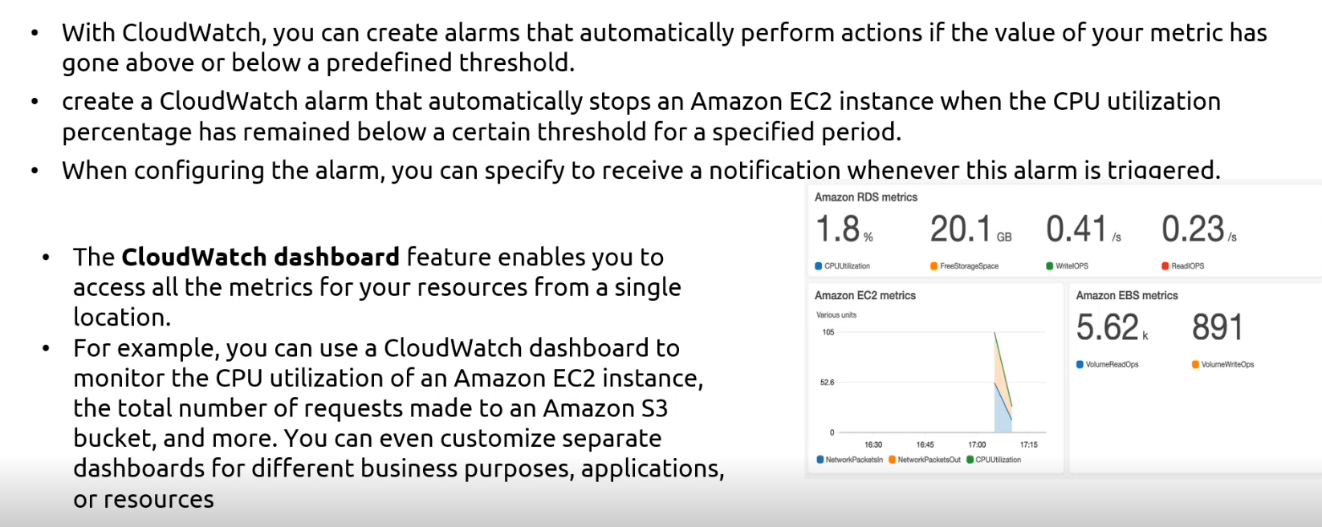

1. **AWS CloudTrail**

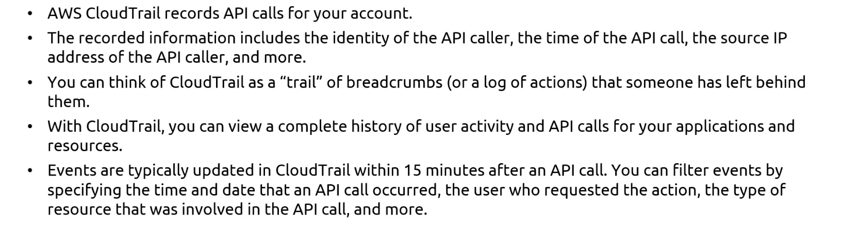

**CloudTrail insights**

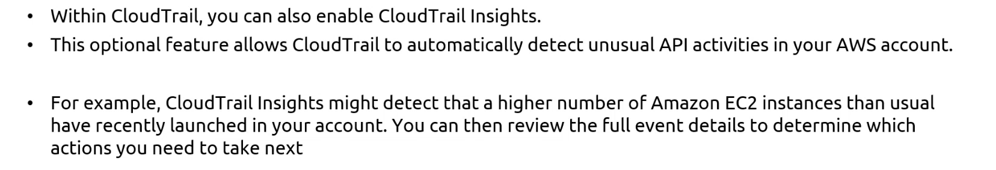

1. **AWS trusted advisor**

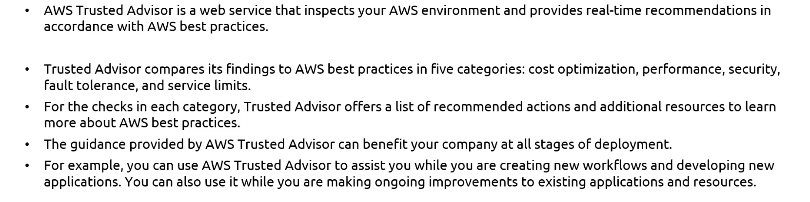

**AWS Trusted advisor dashboard**

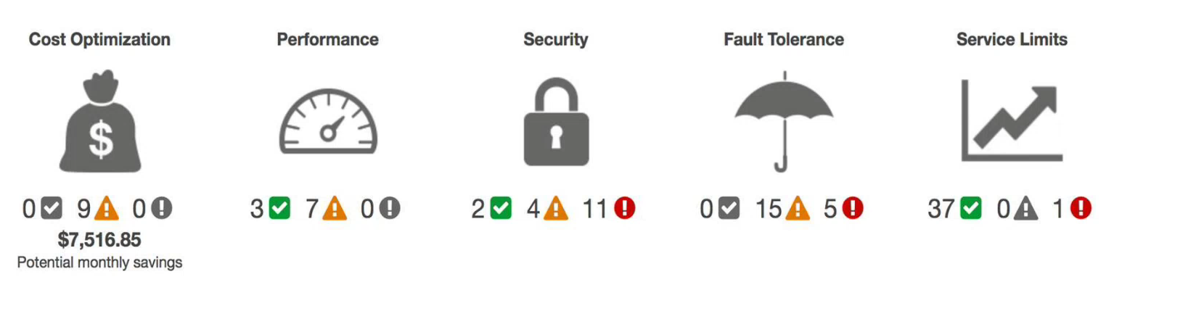

**Module 8: Pricing and Support**

* Understand AWS pricing and support models
* Describe the AWS Free Tier
* Describe key benefits of AWS Organizations and consolidated billing
* Explain the benefits of AWS Budgets
* Explain the benefits of AWS Cost Explorer
* Explain the primary benefits of the AWS Pricing Calculator
* Distinguish between the various AWS Support Plans
* Describe the benefits of AWS Marketplace

1. **AWS free tire**

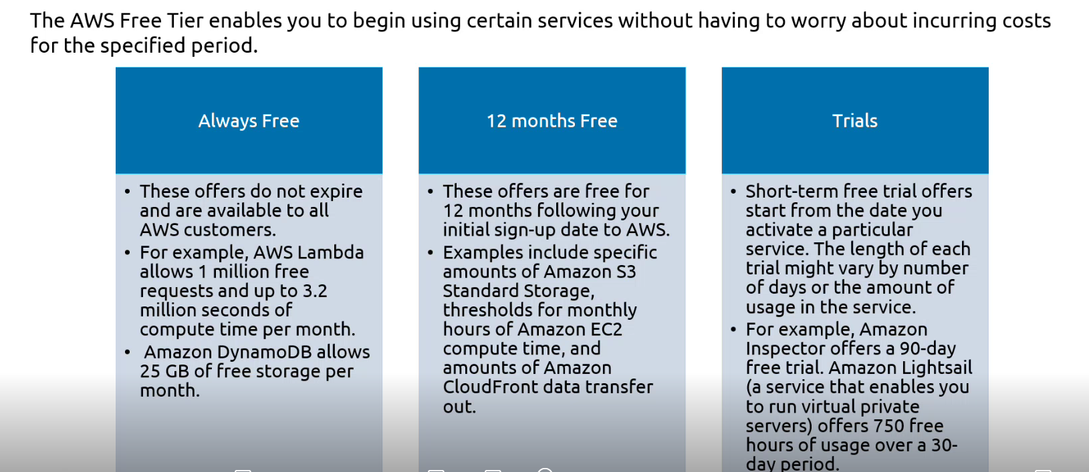

1. **AWS pricing concepts**

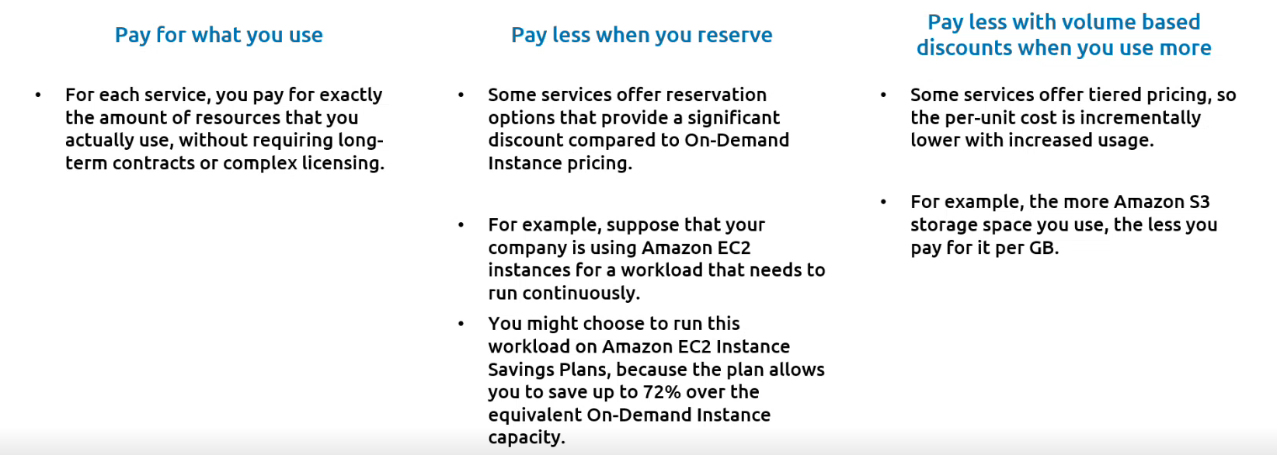

1. **Consolidated billing**

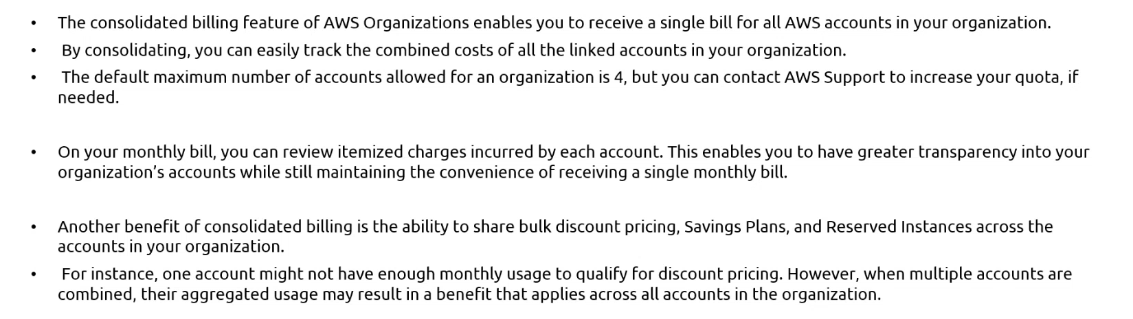

1. **Example of consolidated billing**

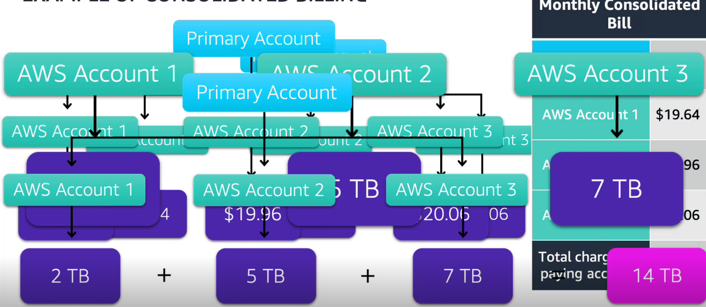

1. **AWS organizations**

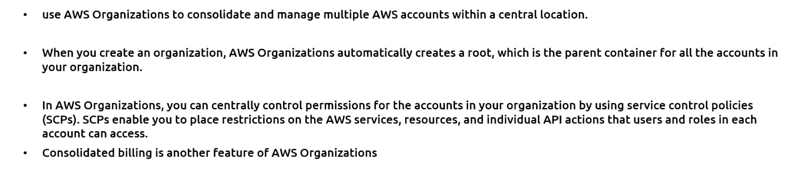

1. **AWS pricing calculator**

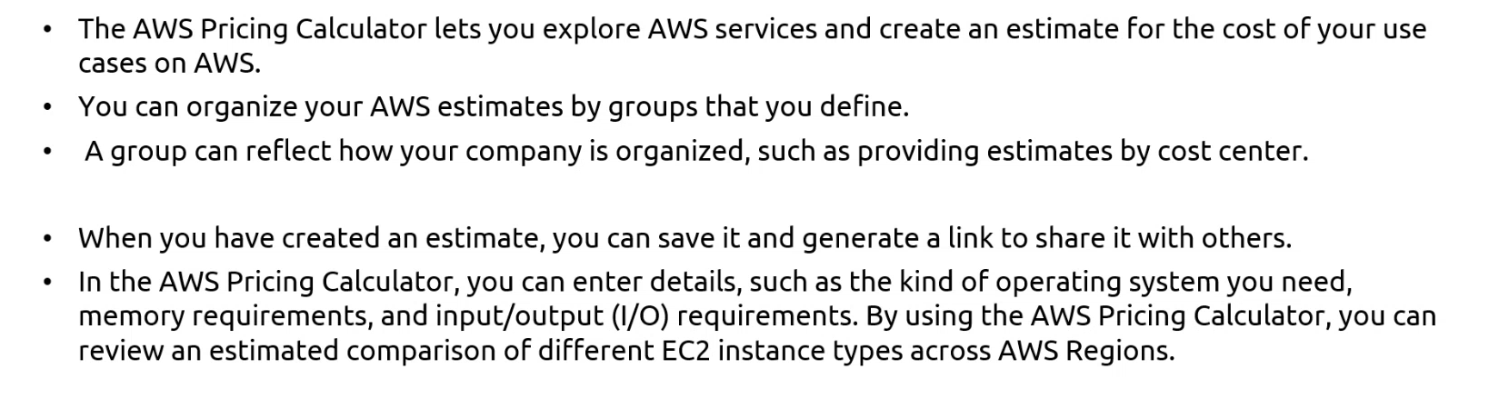

1. **Billing Dashboard**

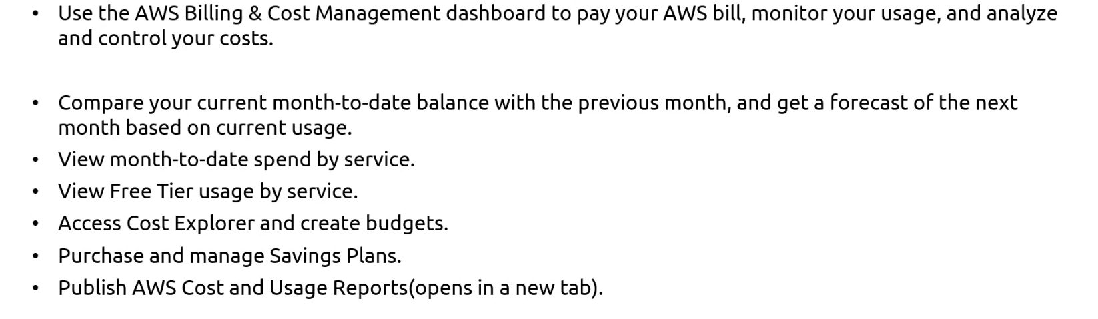

1. **AWS budgets**

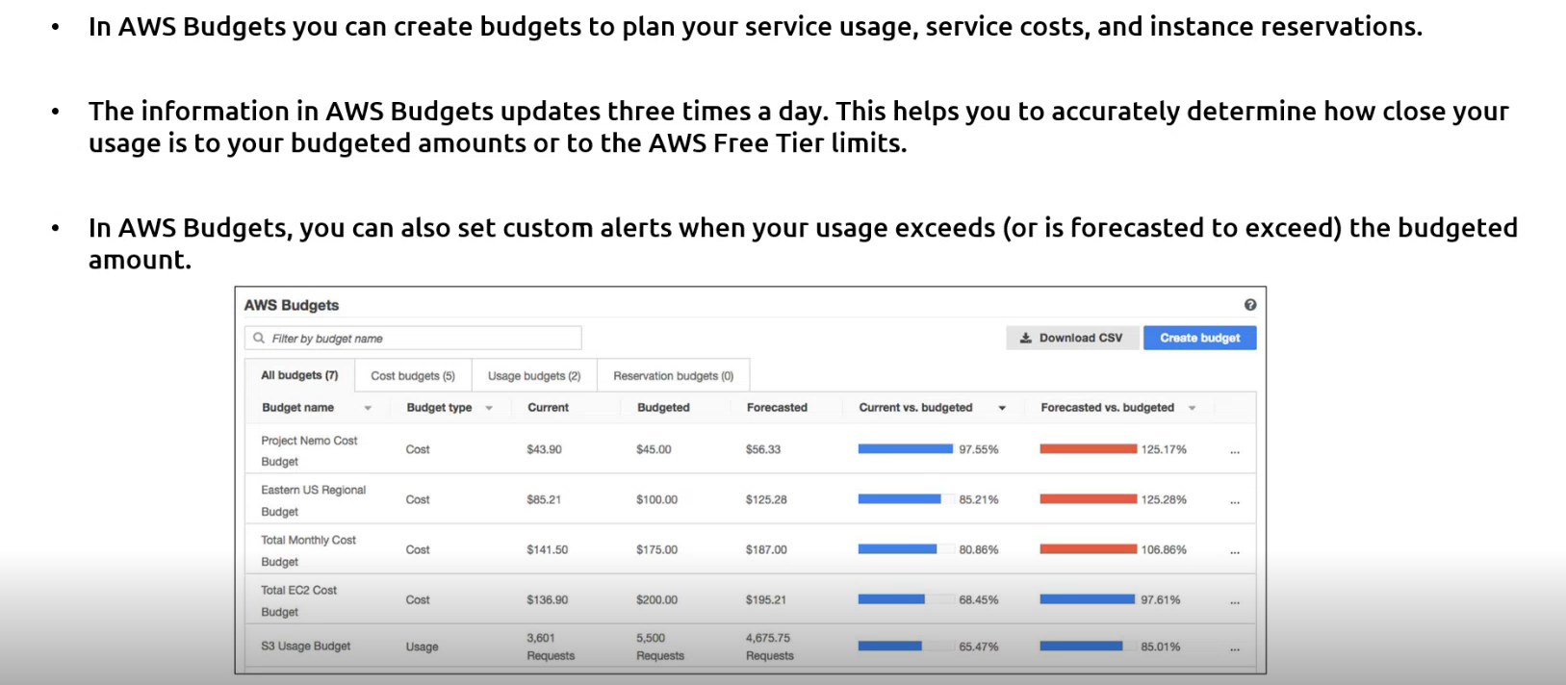

1. **AWS cost Explorer**

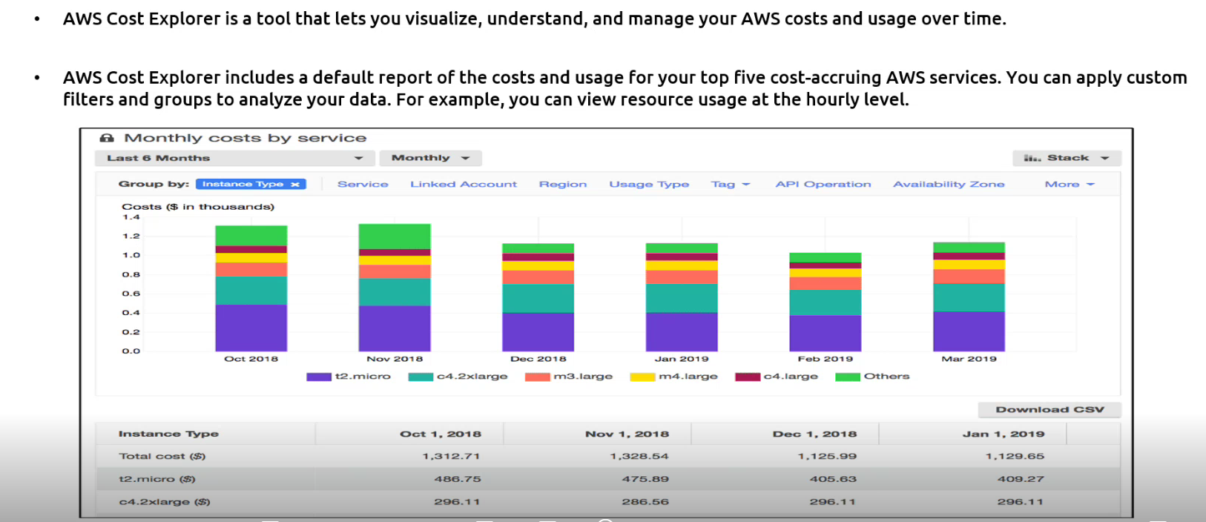

1. **AWS Marketplace**

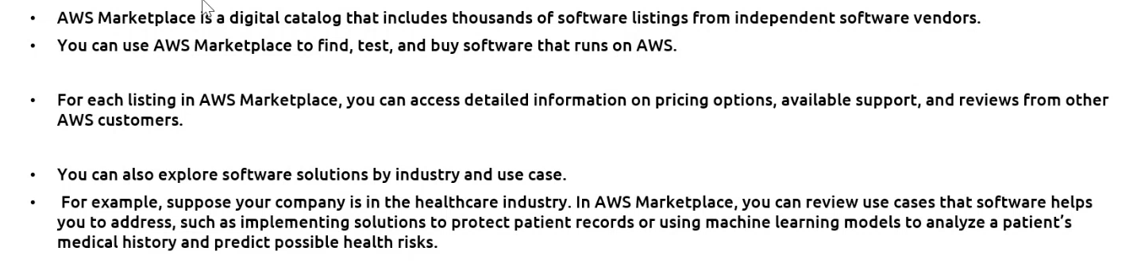

**Module 9: Migration and Innovation**

* Understand migration and innovation in the AWS Cloud
* Summarize the AWS Cloud Adoption Framework (AWS CAF)
* Summarize six key factors of a cloud migration strategy
* Describe the benefits of various AWS data migration solutions, such as AWS Snowclone, AWS Snowball, and AWS Snowmobile
* Summarize the broad scope of innovative solutions that AWS offers

1. **Aws cloud Adoption framework (AWS CAF)**

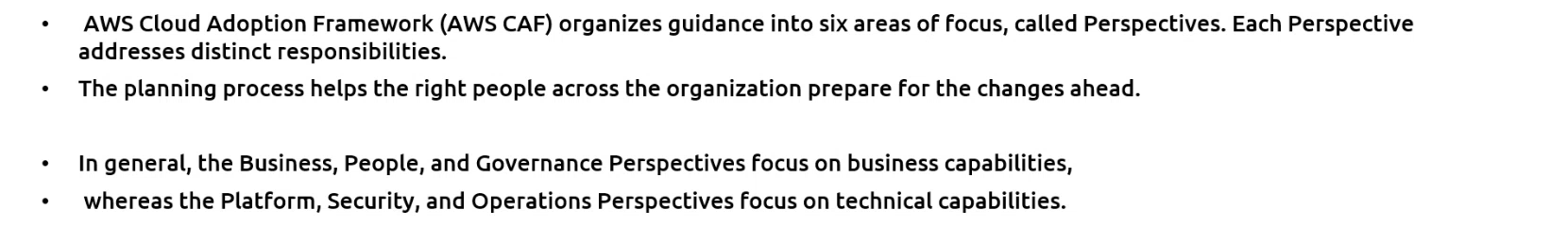

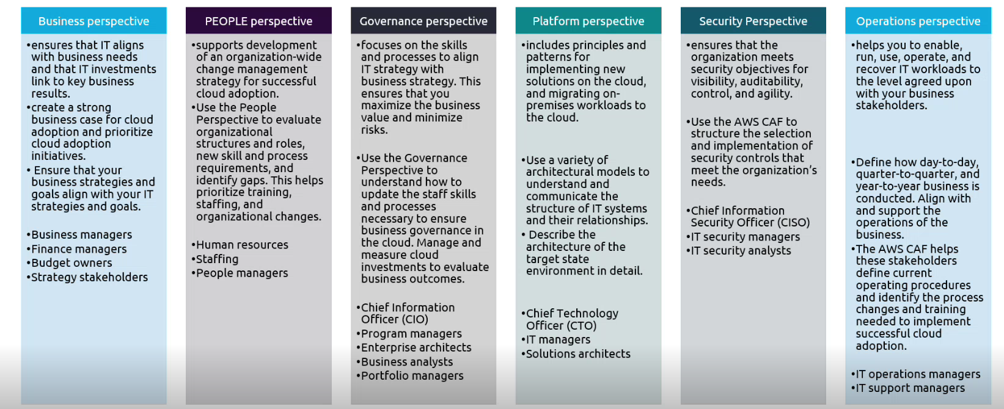

1. **AWS CAF Hypothetical example**

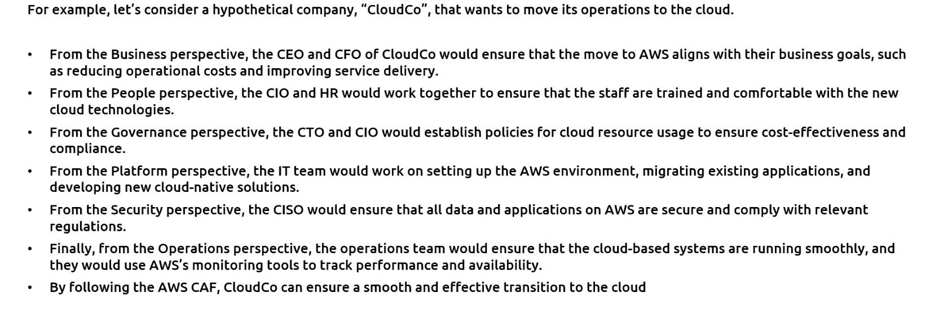

1. **Migration Strategies**

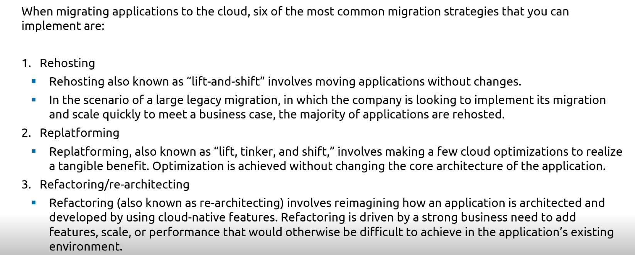

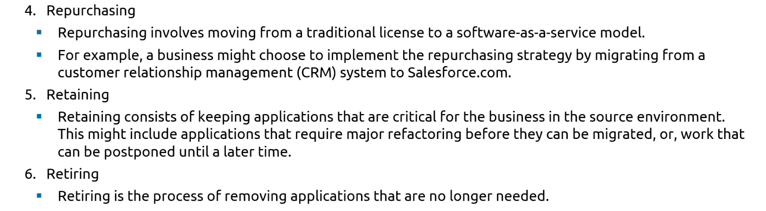

1. **AWS Snow family members**

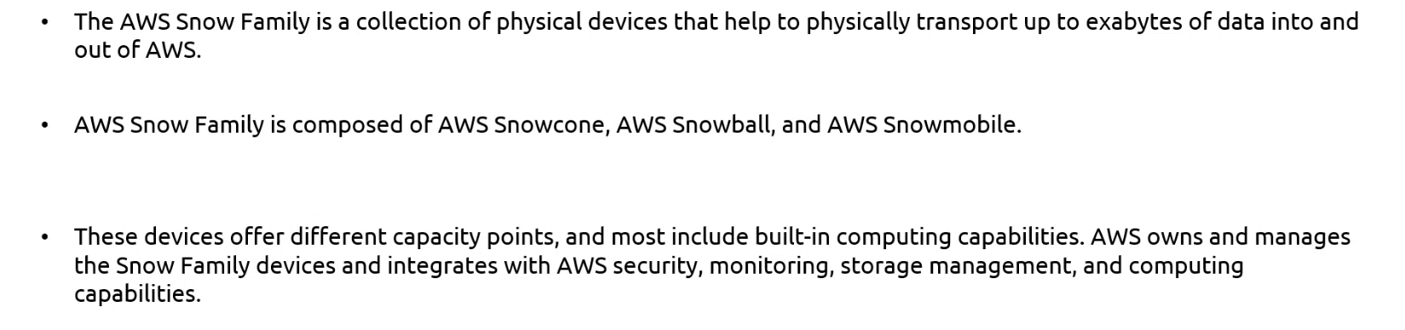

1. **Aws snowcone and snowcone SSD**

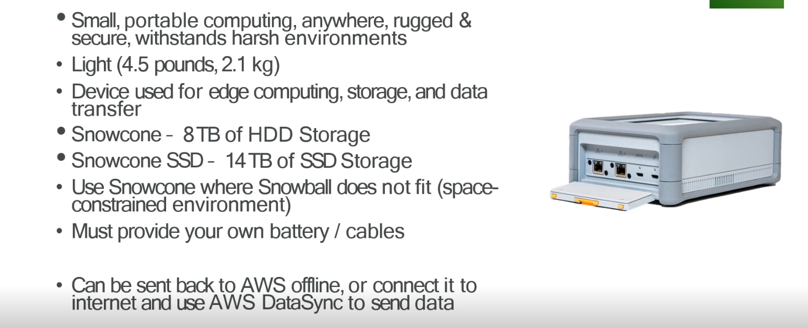

1. **AWS snowball**

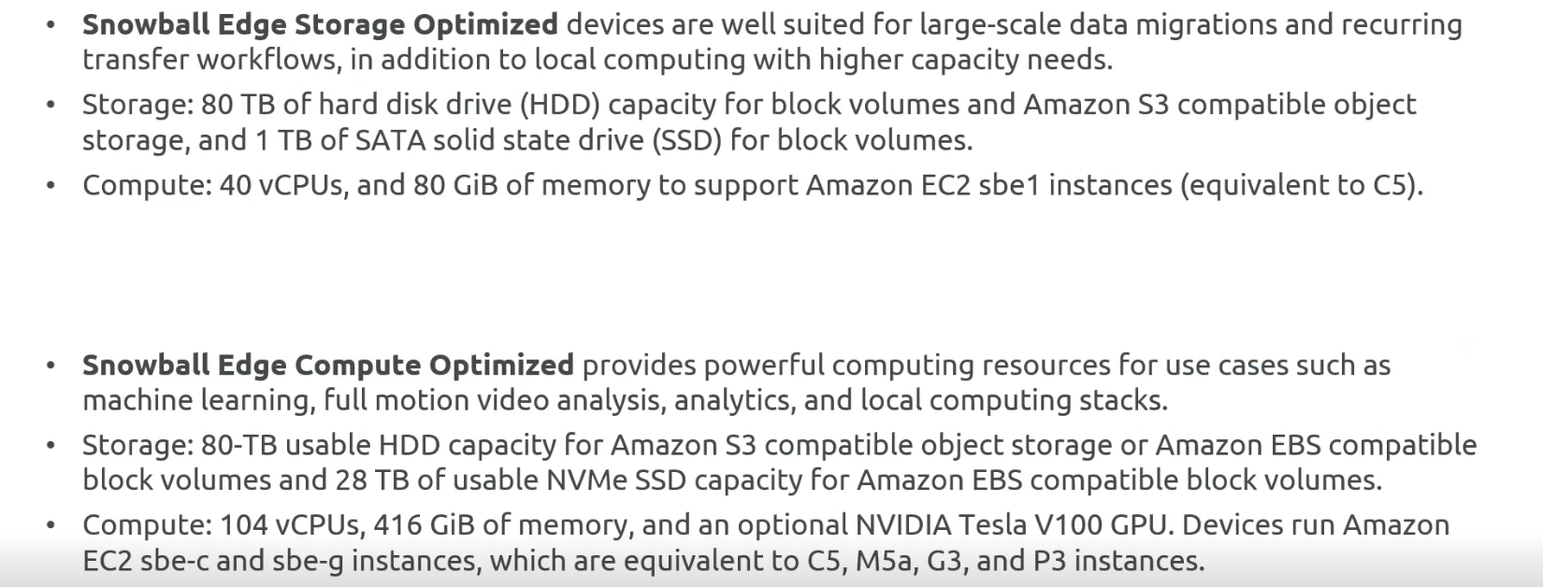

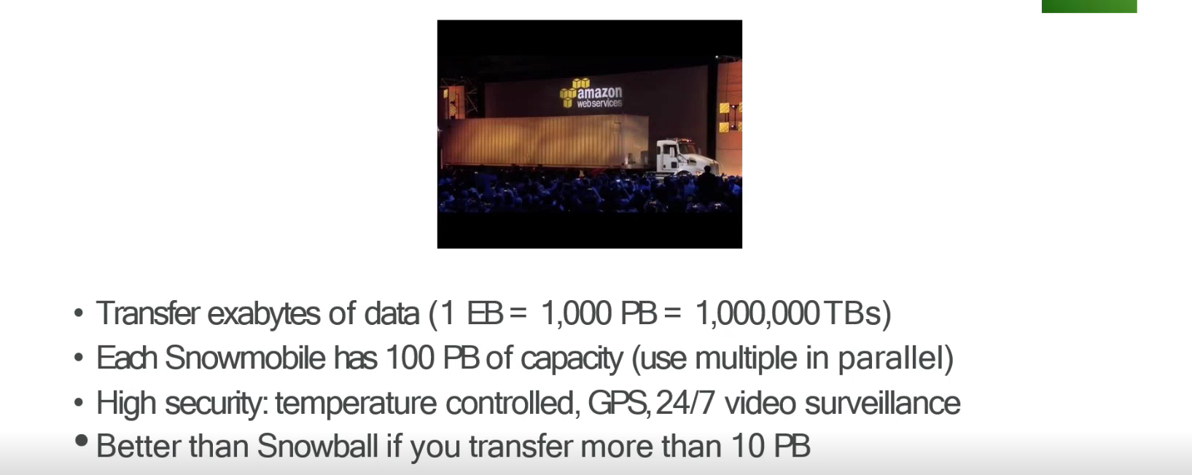

1. **Innovate with AWS Services**

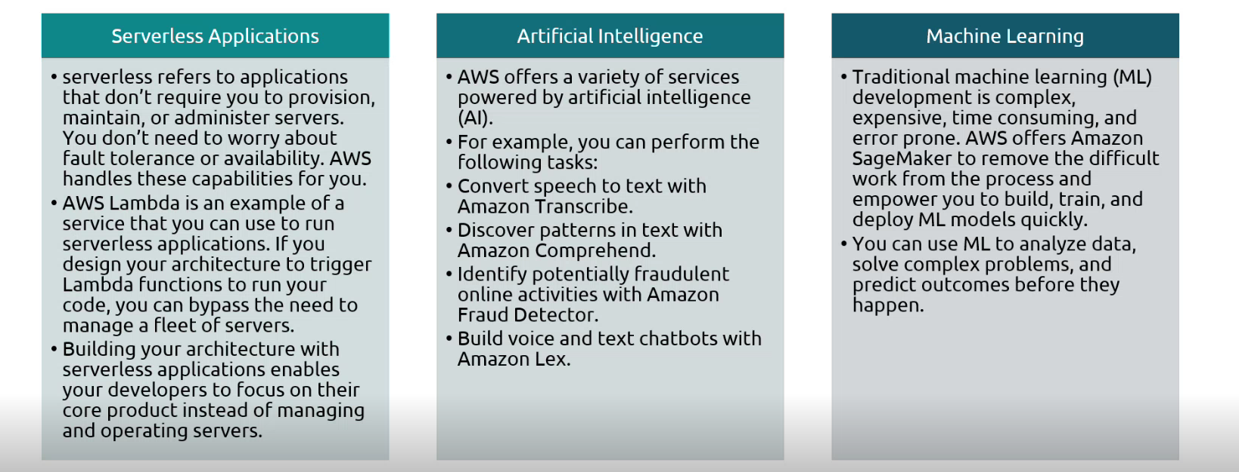

**Module 10: The Cloud Journey**

* Summarize the five pillars of the AWS Well-Architected Framework
* Explain the six benefits of cloud computing

1. **AWS well-architected frameworks**

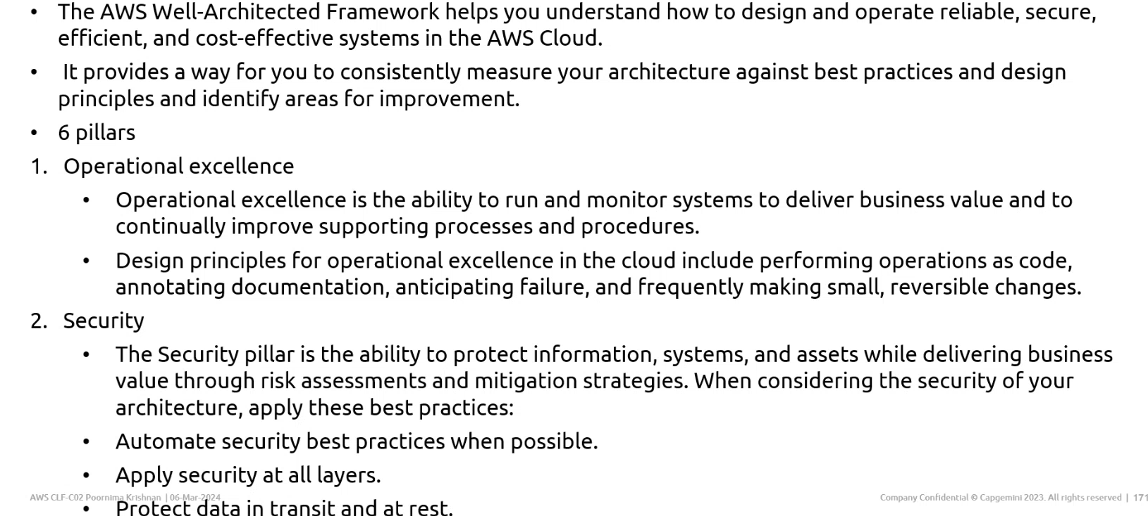

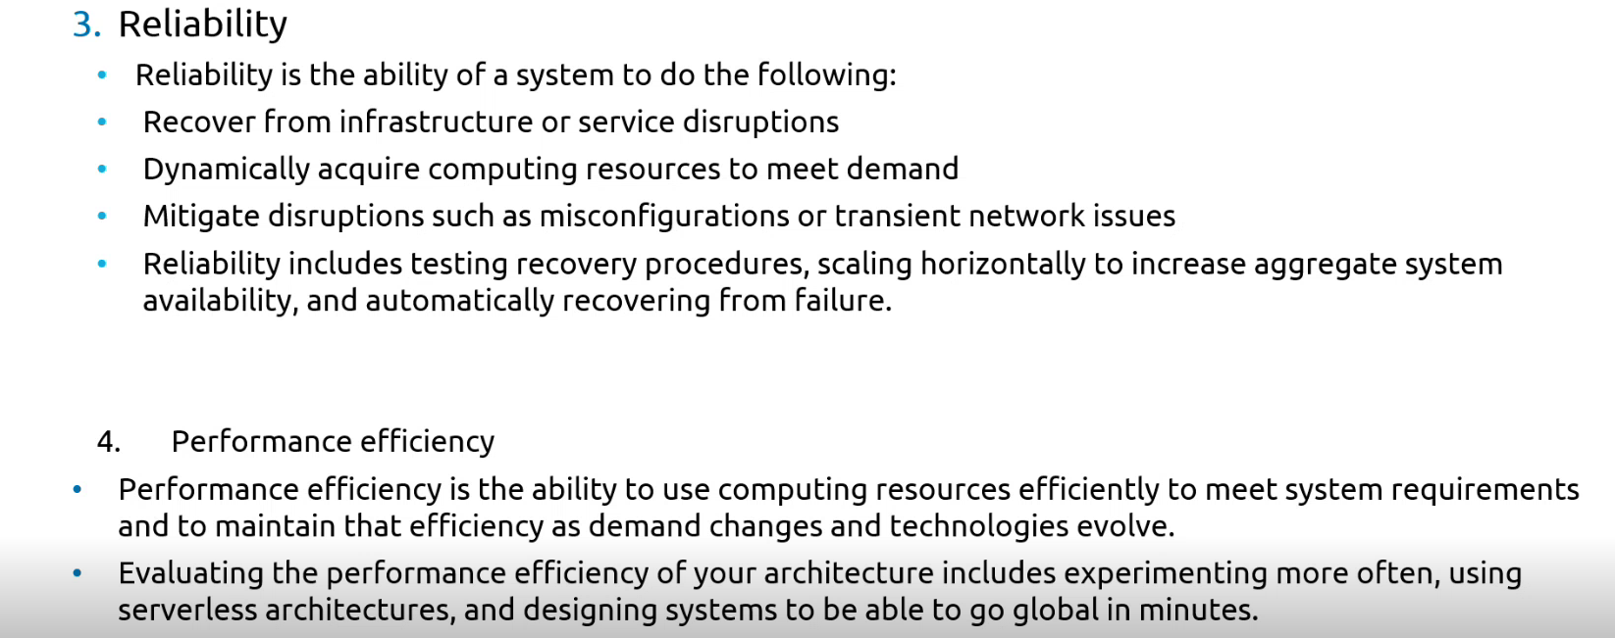

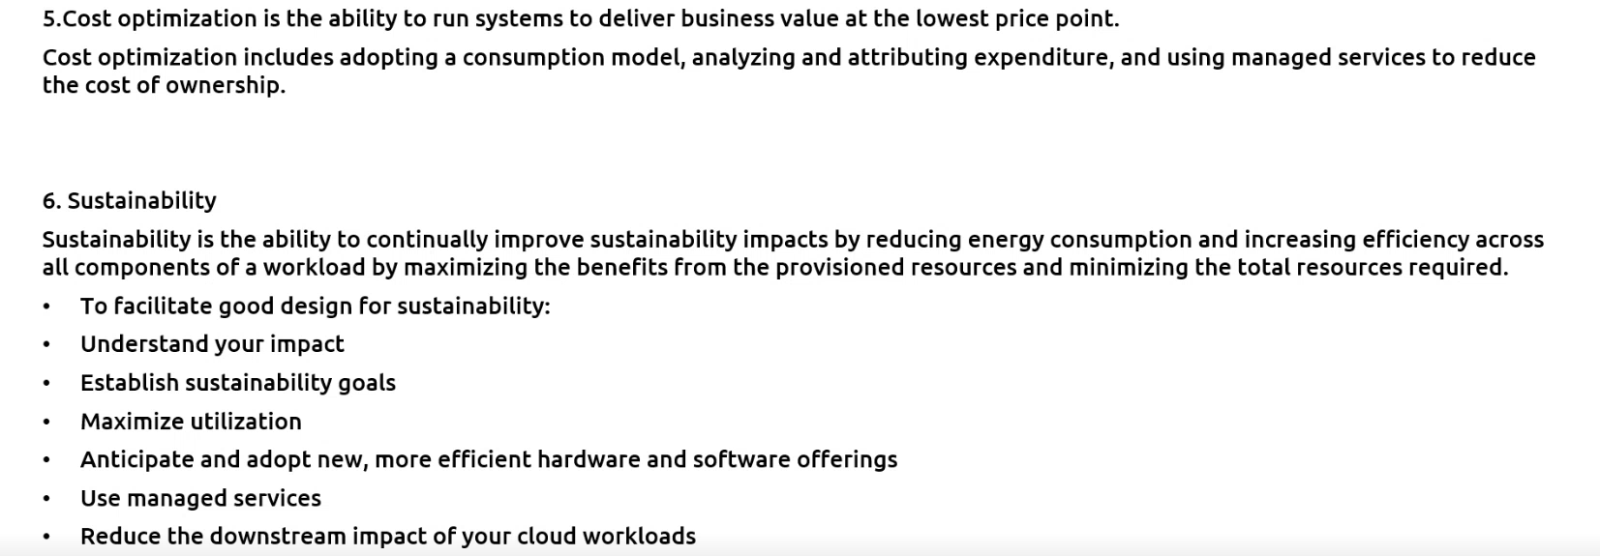

1. **Operational Excellence AWS services**

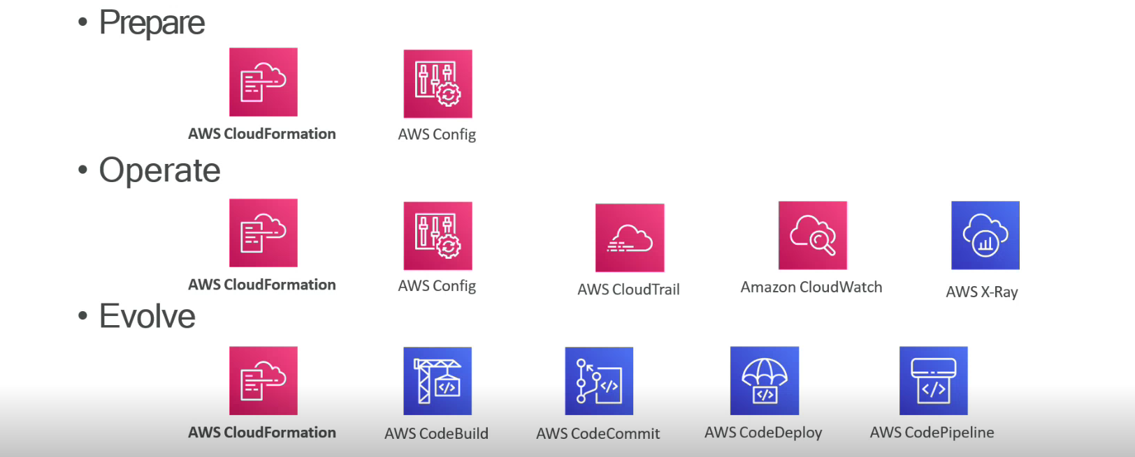

1. **Security AWS services**

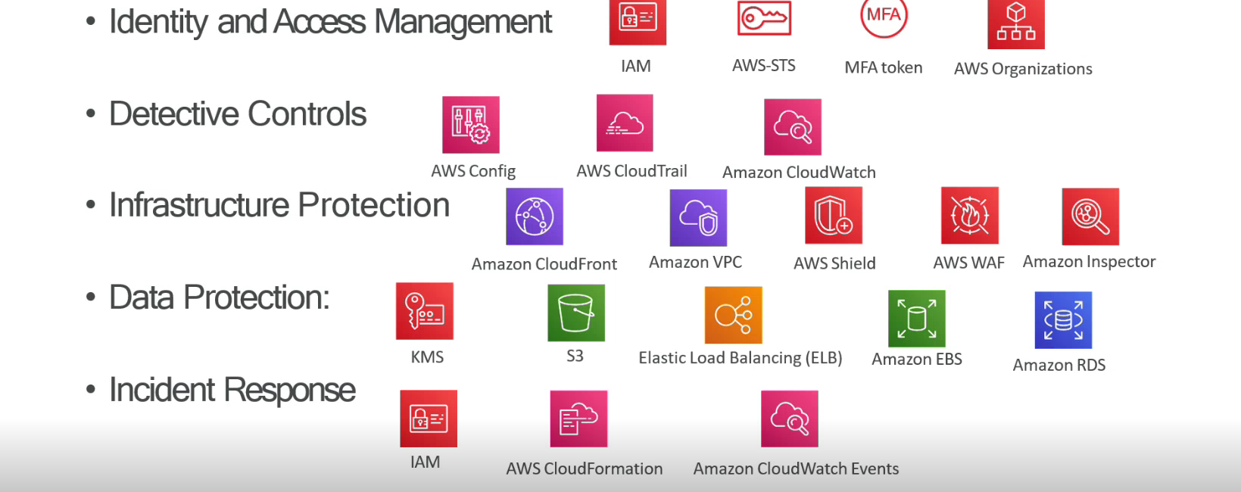

1. **Reliability AWS services**

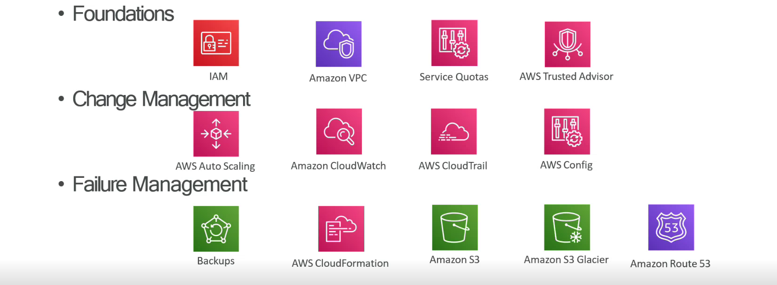

1. **Performance efficiency AWS services**

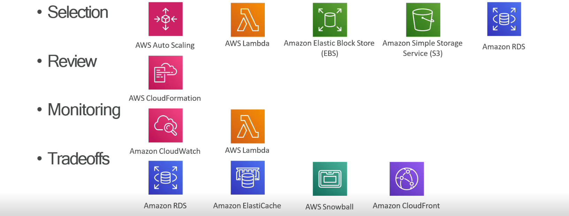

1. **Cost Optimization AWS services**

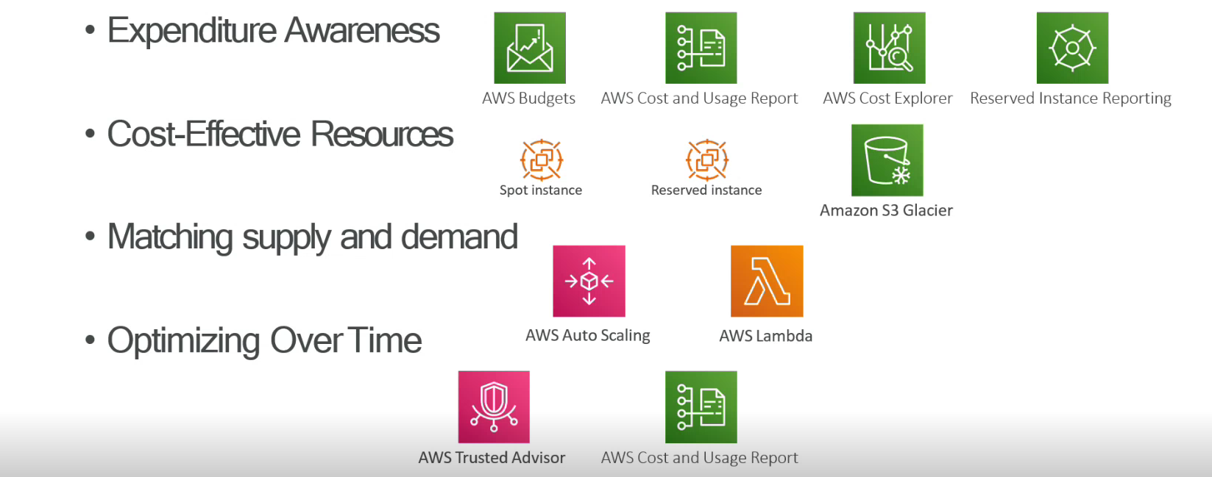

1. **Sustainability AWS services**

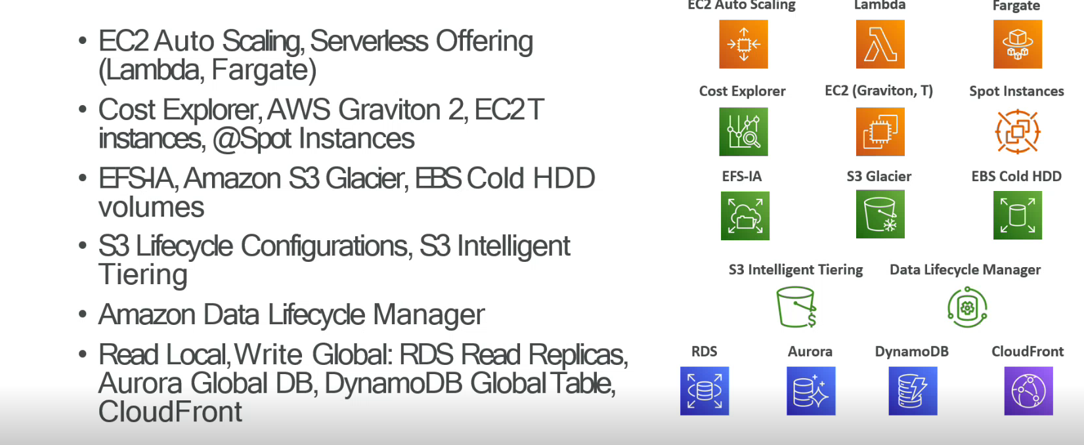

**Module 11: AWS Certified Cloud Practitioner Basics**

* Determine resources for preparing for the AWS Certified Cloud Practitioner examination
* Describe benefits of becoming AWS Certified

**Amazon Web Services (AWS CLF-C02)**

<https://explore.skillbuilder.aws/learn/course/external/view/elearning/134/aws-cloud-practitioner-essentials>

<https://explore.skillbuilder.aws/learn/course/9449/exam-prep-aws-certified-cloud-practitioner-clf-c01>

**Difference of local deployment and Aws deployment**

**Local Deployment** **Aws Deployment**

Everything runs locally and same machine one service=one responsibility

Files stored on server Files served from s3

Database on same server as application Database as a service

Connections done manually Connections done AWS software development kit

For AWS have 170+ services, how can interact with these services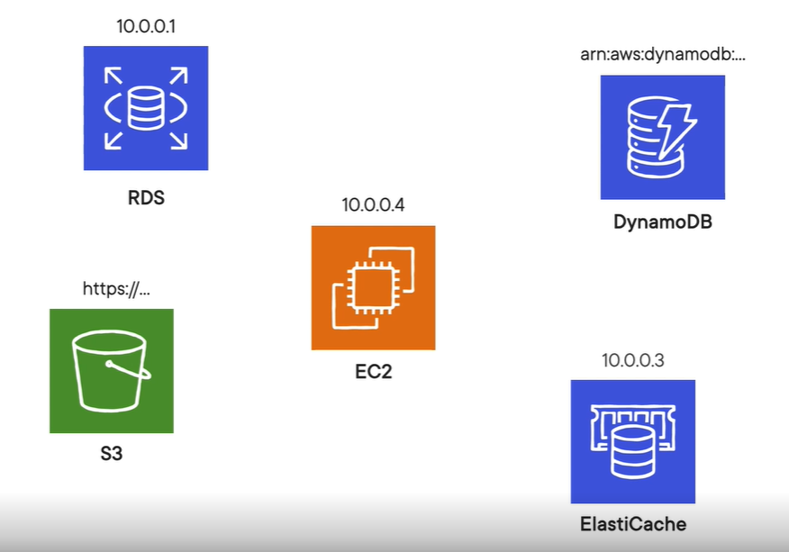

**The core of AWS is Elastic cloud computing (EC2)**

**Amazon Elastic Cloud Compute (Amazon EC2):**

Amazon Elastic Compute Cloud (Amazon EC2) provides secure, resizable compute capacity in the cloud as Amazon EC2 instances.

Imagine you are responsible for the architecture of your company's resources and need to support new websites.

**With traditional on-premises resources, you must do the following:**

* Spend money upfront to purchase hardware.
* Wait for the servers to be delivered to you.
* Install the servers in your physical data centre.
* Make all the necessary configurations.

**By comparison, with an Amazon EC2 instance you can use a virtual server to run applications in the AWS Cloud.**

* You can provision and launch an Amazon EC2 instance within minutes.
* You can stop using it when you have finished running a workload.
* You pay only for the compute time you use when an instance is running, not when it is stopped or terminated.
* You can save costs by paying only for server capacity that you need or want.

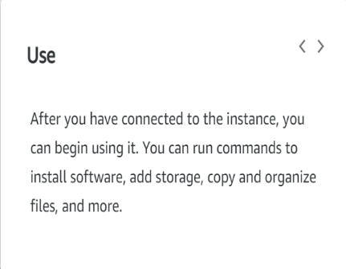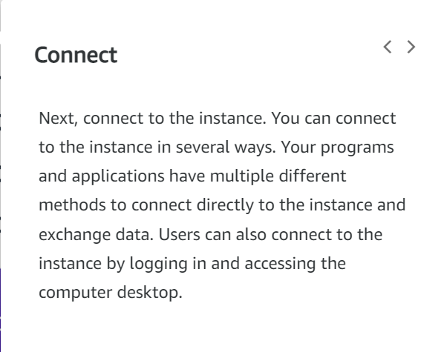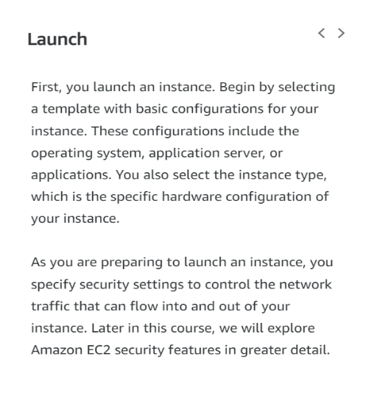**How Amazon EC2 works:**

**Amazon EC2 instance types:**

Amazon EC2 instance types are optimized for different tasks.

When selecting an instance type, consider the specific needs of your workloads and applications. This might include requirements for compute, memory, or storage capabilities.

1. 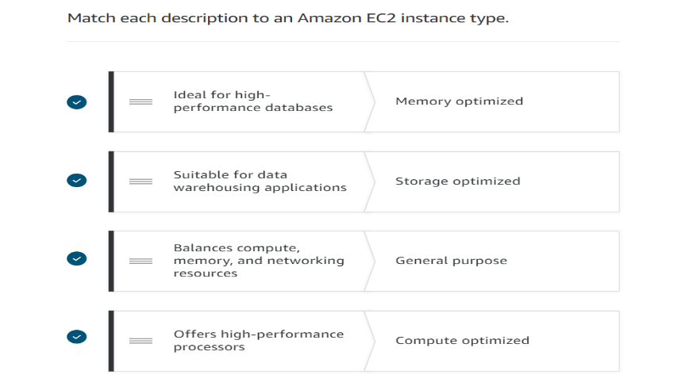**General purpose Instance**

It is used balance compute, memory, and   
 networking resources.

1. **Compute optimized Instance**

Offers high-performance processors

1. **Memory optimized Instance**

Ideal for high performance databases

1. **Storage optimized Instance**

Suitable for data warehousing applications

1. **Accelerated computing Instance**

Use hardware accelerators, or co-processors, or  
 data pattern machine

**Amazon EC2 prising:**

Amazon EC2 purchase options

1. **On-Demand**

* It's the pay-as-you-go model
* Standard rate-no discount; no commitments; dev/test, sort term or unpredictable workloads.

1. **Savings Plans**

* Savings Plans are a flexible pricing model that offers low prices on EC2 and Faregate usage, in exchange for a commitment to a consistent amount of usage (measured in $/hour) for a one - or three-year term.

1. **Reserved Instances**

* It purchases are one of the easiest ways to start reducing cloud spends.
* One- or three-year commitment.
* In return for that long-term commitment, AWS gives a hefty discount of up to 72% off compared to the On-Demand prices.

1. **Spot Instances**

* It allows you to take advantage of Amazon's 'extra' capacity.
* They are offered at a deep discount of up-to 90% off the On-Demand EC2 prices.
* Spot Instance are flexible start and end time.

1. **Dedicated hosts**

* A Dedicated Host is a physical EC2 server dedicated for your use.
* Dedicated Hosts can help you reduce costs by allowing you to use your existing server-bound software licenses, including Windows Server, SQL Server, and SUSE Linux Enterprise Server (subject to your license terms), and can also help you meet compliance requirements.

**Scaling Amazon EC2:**

**Scalability**

Scalability involves beginning with only the resources you need and designing your architecture to automatically respond to changing demand by scaling out or in. As a result, you pay for only the resources you use. You don’t have to worry about a lack of computing capacity to meet your customers’ needs. If you wanted the scaling process to happen automatically, which AWS service would you use? The AWS service that provides this functionality for Amazon EC2 instances is Amazon EC2 Auto Scaling**.**

**Amazon EC2 Auto Scaling:**

Amazon EC2 Auto Scaling enables you to automatically add or remove Amazon EC2 instances in response to changing application demand.

By automatically scaling your instances in and out as needed, you can maintain a greater sense of application availability. Within Amazon EC2 Auto Scaling, you can use two approaches: dynamic scaling and predictive scaling.

* Dynamic scaling responds to changing demand.
* Predictive scaling automatically schedules the right number of Amazon EC2 instances based on predicted demand.

**Ex**: When you create an Auto Scaling group, you can set the minimum number of Amazon EC2 instances. The minimum capacity is the number of Amazon EC2 instances that launch immediately after you have created the Auto Scaling group. In this example, the Auto Scaling group has a minimum capacity of one Amazon EC2 instance.

**Elastic Load Balancing:**

Elastic Load Balancing is the AWS service that automatically distributes incoming application traffic across multiple resources, such as Amazon EC2 instances.

A load balancer acts as a single point of contact for all incoming web traffic to your Auto Scaling group. This means that as you add or remove Amazon EC2 instances in response to the amount of incoming traffic, these requests route to the load balancer first. Then, the requests spread across multiple resources that will handle them.

**For example**, if you have multiple Amazon EC2 instances, Elastic Load Balancing distributes the workload across the multiple instances so that no single instance must carry the bulk of it. Although Elastic Load Balancing and Amazon EC2 Auto Scaling are separate services, they work together to help ensure that applications running in Amazon EC2 can provide high performance and availability.

**Low-demand period:**

Here’s an example of how Elastic Load Balancing works. Suppose that a few customers have come to the coffee shop and are ready to place their orders.

If only a few registers are open, this matches the demand of customers who need service. The coffee shop is less likely to have open registers with no customers. In this example, you can think of the registers as Amazon EC2 instances.

**High-demand period:**

Throughout the day, as the number of customers increases, the coffee shop opens more registers to accommodate them. In the diagram, the Auto Scaling group represents this.

Additionally, a coffee shop employee directs customers to the most appropriate register so that the number of requests can evenly distribute across the open registers. You can think of this coffee shop employee as a load balancer.

**Messaging and queuing:**

Monolithic application and microservices:

**Monolithic application:**

Applications are made of multiple components. The components communicate with each other to transmit data, fulfil requests, and keep the application running.

Suppose that you have an application with tightly coupled components. These components might include databases, servers, the user interface, business logic, and so on. This type of architecture can be considered a monolithic application.

In this approach to application architecture, if a single component fails, other components fail, and possibly the entire application fails.

To help maintain application availability when a single component fails, you can design your application through a microservices approach.

**Microservices application:**

In a microservices approach, application components are loosely coupled. In this case, if a single component fails, the other components continue to work because they are communicating with each other. The loose coupling prevents the entire application from failing.

When designing applications on AWS, you can take a microservices approach with services and components that fulfil different functions. Two services facilitate application integration: Amazon Simple Notification Service (Amazon SNS) and Amazon Simple Queue Service (Amazon SQS).

**Amazon Simple Notification Service (Amazon SNS):**

Amazon Simple Notification Service (Amazon SNS) is a publish/subscribe service. Using Amazon SNS topics, a publisher publishes messages to subscribers. This is like the coffee shop; the cashier provides coffee orders to the barista who makes the drinks.

In Amazon SNS, subscribers can be web servers, email addresses, AWS Lambda functions, or several other options.

**Amazon Simple Queue Service (Amazon SQS):**

Amazon Simple Queue Service (Amazon SQS) is a message queuing service.

Using Amazon SQS, you can send, store, and receive messages between software components, without losing messages or requiring other services to be available. In Amazon SQS, an application sends messages into a queue. A user or service retrieves a message from the queue, processes it, and then deletes it from the queue.

**AWS CLI (Command line interface) features**

Great for shell shifting, feature complete with console and SDKs, Interact with any service

AWS CLI made for operations engineers more than developers

Usages: Configure local development environment and alternative to console actions.

**AWS SDK (Software Development Kit) features**